Куликова Ирина Максимовна, учитель английского языка, Академическая гимназия №56 г. Санкт-Петербурга
Данное учебное пособие представляет собой сборник увлекательных рассказов и статей зарубежных авторов, знакомящих учащихся с материалом по страноведению и культурой народов мира. Тексты сборника адаптированы в учебных целях до уровня Pre-Intermediate и дополнены словарями и упражнениями, направленными на проверку понимания текста, отработку лексики и грамматических структур, а также на развитие устной речи.
Книга адресована учащимся 6 классов средних школ и гимназий, а также широкому кругу лиц, изучающих английский язык самостоятельно или под руководством преподавателя.
Основная функция чтения на английском языке – это расширение словарного запаса учащегося. Незнакомые слова представлены в контексте, что в значительной степени улучшает запоминание их значений, а заучивание наизусть отрывков текста и пересказ даже положено в основу одного из методов изучения английского языка. Немаловажная роль в процессе чтения на английском языке отводится использованию словаря. Небольшой словарь в конце каждого текста станет помощником в переводе. Альтернативным решением этой проблемы может быть использование электронных словарей. Не стоит пренебрегать и составлением собственного словарика незнакомых слов.
Интересные и разнообразные задания сделают изучение страноведческого материала более привлекательным для учащихся. Рекомендуем преподавателям подбирать видео материал к данному пособию. Видео материал, подобранный к текстам, позволит не только представить праздники, легенды и истории разных стран, но и увидеть, как это происходит или происходило в прошлом.
ПЕЧАТАЕТСЯ ПО РЕШЕНИЮ
РЕДАКЦИОННО-ИЗДАТЕЛЬСКОГО ОТДЕЛА
ГБОУ «АКАДЕМИЧЕСКАЯ ГИМНАЗИЯ №56» САНКТ-ПЕТЕРБУРГА

СБОРНИК ТЕКСТОВ ДЛЯ ДОМАШНЕГО ЧТЕНИЯ
(английский язык, 6 класс)
Учебное пособие

Руководитель проекта: Куликова И.М.
Авторы-составители: З.В.Зимина, М.В.Криволесова, М.М.Хорева, И.М.Куликова, Н.З.Кутепова, Е.Д.Лаевская, А.В.Малиновская, Н.С.Маталина, Е.Д.Таликина, И.Г.Назарова, О.М.Рыкова, Е.А.Райтер, А.В.Сулимова

Дизайн, верстка: М.М.Хорева, И.М. Куликова

©ГБОУ «Академическая гимназия №56», 2021

CONTENTS

British emblems 3
Eton College 6
Oxbridge 10
Bonfire Night 12
Christmas Down Under 17
Diwali 20
Stonehenge 24
The Giant’s 27
New Zealand 31
The History of the Cape Town Minstrel Carnival 34
СПИСОК ИСПОЛЬЗОВАННЫХ ИСТОЧНИКОВ И ЛИТЕРАТУРЫ 37

British emblems

The United Kingdom of Great Britain and Northern Ireland consists of four countries – Wales, England, Scotland and Northern Ireland. Each of the counties has its unique historical and cultural features but, at the same time, they have very much in common.
Union Jack
Union Jack is the name of the official British flag. Its history reflects the history of the whole country. Many centuries ago England, Scotland, Wales and Ireland were deadly enemies. Then England conquered Wales and in the 16-th century they became one kingdom. Saint George’s Cross (a red cross on a white background) became the state symbol because St. George was their patron saint. In 1603 Scotland joined the kingdom. St. Andrew’s Cross (patron saint of Scotland) appeared on the flag. It was a diagonal white cross on a blue background. However, changes did not stop there. In 1800 Ireland became part of Great Britain. In 1801, the Union Flag was redesigned to include the Cross of St. Patrick (a red, diagonal cross on a white background), the patron saint of Ireland. It is in this form that the British flag exists today.
The red rose
From 1455 to 1485 two noble families were fighting to get the English throne. The white rose was the emblem of the Lancastrians; the red rose was the emblem of the Yorkists. None of the families could win. The war between the roses stopped when Henry VII, the Lancastrian, married Princess Elizabeth, the Yorkist. The red rose has since become the national emblem of England.
The thistle
A legend says that once Norsemen landed on the east coast of Scotland. The Scots gathered with their arms in a fortress behind the river Tay. As they marched all day and were very tired, they got asleep, noble the enemy before the next day. The Norsemen, however, were near. They saw no guards at the Scottish camp and decided to kill them in their sleep. So, they took off their shoes to make no noise but one of the Norsemen stepped on a thistle. The sudden and sharp pain made him to shriek. The alarm was given and the Scots won the battle. After that the Scots took the thistle as their national emblem.
The leek and the daffodil
On St. David’s Day (the first of March) Welshmen always wear leeks or daffodils. They believe that St. David lived for several years only eating bread and wild leeks. However, some people prefer to wear the daffodil because it blooms on that day. Besides, they think that the daffodil is more beautiful.
The shamrock
On the 17-th of March the Irish celebrate St. Patrick’s Day. The symbol of the day is the shamrock. St. Patrick, an early Christian priest, used this small white clover with three leaves to tell the pagans about the mystery of Christianity. Nowadays the Irish wear this flower in memory of their patron saint.

Vocabulary

1.Сonsists – состоит
2.Unique – уникальный
3. In common – общее
4. Deadly enemies – смертельные враги
5. Conquered – завоевал
6. Diagonal – диагональный
7. Background – зд. фон
8. Exists – существует
9. Noble – благородные
10. Not expecting – не ожидая
11. Thistle - чертополох
12. Leeks – лук-порей
13. Daffodils – нарциссы
14. Blooms – цветёт
15. Priest - священник

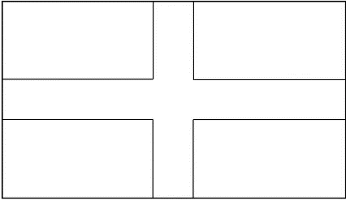
- Read the text about Union Jack and colour the flags. Then write down their names.
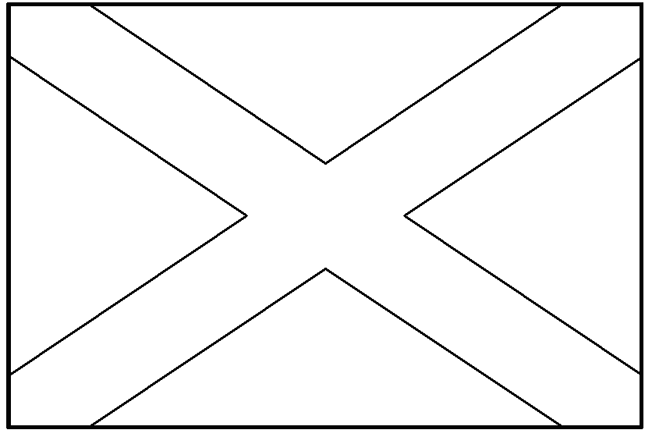
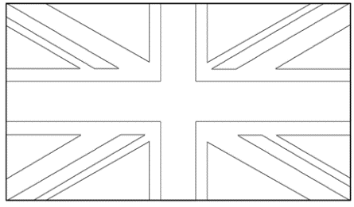
- Read the articles about British emblems and match the sentences with the countries.
The Lancastrians’ emblem was the white rose. | Wales
A Norseman stepped on a thistle and shrieked.
St. David only ate bread and wild leeks for several years. | England
The 17-th of March is St. Patrick’s Day.
Two noble families were fighting to get the throne. | Northern Ireland
The shamrock is a small clover with three leaves.
They saw no guards at the camp. | Scotland
Some people wear the daffodil on the 1-st of March.

- Say if the statements are true, false or there is no information.

- The war between roses lasted for 30 years.
- Henry VII loved Princess Elizabeth very much.
- The daffodil flowers on St. David’s Day.
- The Irish wear the shamrock in memory of their victory in a war.
- In 1801 Union Jack was redesigned for the last time.
- Once Norsemen landed on the west coast of Scotland.
- The river Tay is very long and wide.
- St. Patrick was a Christian priest.
- A Norseman stepped on a thistle and shrieked because he had no shoes on.
- The white rose is the emblem of England.

- Fill in the missing letters
w-ol-, -ent-r-, con- -er, I-el-nd, kin- - om, t-is-le, fo-t-es-, g-a-d, a-a-m, sh-i-k, d-f-o-il,
s-am-ock, p-g-ns, p-i-st.

- Answer the questions and then retell the legend about the thistle.

- Where did Norsemen land?
- Where did the Scotts gather?
- Why did the Scotts get asleep?
- Why did the Norsemen decide to attack the Scottish camp?
- What did they do?
- Why din one of the Norsemen shriek?
- Why did the Scotts win the battle?
- What flower became the Scottish national emblem?

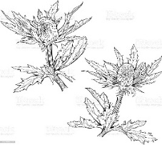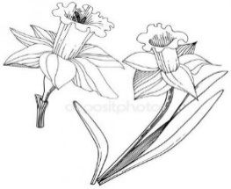

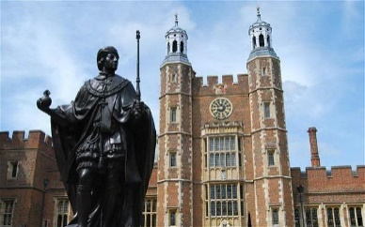
Eton College
Eton College is one of the most famous schools in the world. It is the school for boys only. It is located in the small town of Eton, next to Windsor that is famous for Windsor Castle, the official residence of the Queen. Prince William and Prince Harry, Queen’s grandsons, studied in Eton College.
Eton was founded by King Henry VI in 1440. The king was only 18 at that time. His aim was to give education to poor boys so that they could then go to Cambridge University. The chosen boys had to “have a good character, be good at reading, Latin grammar and singing”. If they “behaved badly, married, or wanted to become monks”, they had to leave.
The life in Eton was hard. Rats ran free about the college, boys had to get up at 5 o’clock in the morning and all lessons were in Latin.
Today, Eton is the largest, most prestigious and very expensive public school for boys in Britain. To get into the college boys have to pass entrance exams first.
Many famous people studied in Eton: the novelists Henry Fielding, George Orwell, Aldous Huxley, Percy Shelley and Ian Fleming, 18 British prime ministers, including David Cameron and Boris Johnson.
Eton is a boarding school where boys live and study away from home. Each boy has his own small room with a bed and desk. Eton students wear a strange old-fashioned school uniform. It consists of a black tailcoat, black pin-striped trousers, a black waistcoat, well-polished black shoes and a white tie. In the past Eton students also wore a top-hat and a walking-cane.
Teachers also wear a uniform, consisting of a white bow-tie, black jacket and striped trousers.
Eton gives a very good education. Every boy takes at least two modern languages chosen from French, German, Japanese, Russian and Spanish. Students also study Latin for at least one year and many choose to study Greek as well. Outside the main timetable they may choose Chinese or Arabic.
At college there are about fifty societies and clubs. Eton is famous for its theatre. Senior boys may take part in military training. Students can do 30 different sports including rugby, football, cricket, rowing, hockey, basketball, swimming and many others.
A personal tutor looks after the progress of every boy. Leaving Eton, students usually enter the top universities of the country, such as Oxford or Cambridge.

Vocabulary
- Aim - цель
- Behave – вести себя
- Monk - монах
- Public school – частная школа
- Entrance exams – вступительные экзамены
- Novelists – романист (писатель, который пишет романы)
- Including - включая
- Boarding school – пансион, интернат
- Consist of – состоять из
- Tailcoat - фрак
- Pin-striped – полосатый (в очень узкую полоску)
- Waistcoat - жилет
- Well-polished – хорошо начищенный (об обуви)
- Tie - галстук
- Top-hat - цилиндр
- Walking cane - тросточка
- Bow-tie – галстук-бабочка
- At least – по крайней мере
- Senior – старший
- Society - общество
- Military training – военная подготовка
- Rowing – гребля
- Personal tutor – личный наставник

- Match the words with the definitions.

a walking cane | a school for children 13-18 years old whose parents pay for their education
entrance exams | a man who lives in a monastery
top hat | something who hope to achieve
public school | a jacket which is short at the front with two long pieces at the back
monk | a special training for the army, navy or airforce
tailcoat | special exams a person has to pass to become a student
military training | a school where students study and live
aim | a tall, usually black or grey, hat now worn on formal occasions
boarding school | a long stick that people use to help them to walk

- Complete the gaps with the correct form of the words in the left.

- Eton College is one of ________________ schools in the world. | FAMOUS
- The boys had to be good at reading and _______. | SING
- If they behaved ____________, they had to leave. | BAD
- Many famous _____________ studied in Eton. | PERSON
- Eton __________wear a special uniform. | STUDY
- Eton gives a very good ______________. | EDUCATE
- Many students choose to study ____________. | GREECE
- After Eton student ____________ enter the best universities in the country. | USUAL

- Fill in the gaps with prepositions.
- One ____ the most famous schools
- The official residence ____ the Queen
- to be founded ____ 1440
- to be founded ______ Henry VI
- to be good _____ reading
- to get ______ the college
- to consist _______
- _____ least two modern languages

- Read the sentence. Circle the correct answer.
- Eton College is a school for_______________
- Girls only/ both boys and girls/ boys only
- Eton was founded by ____________ in 1440.
- Elizabeth I/ Henry VI/ Henry VIII
- His aim was to give education to_______ boys.
- Poor/ rich/ noble
- The chosen boys had to be good at _________ grammar.
- English/ Latin/ French
- Eton students ________________
- Have no uniform/ can wear casual clothes/ have to wear a special uniform

- Answer the questions and retell the text
- Who studies in Eton?
- Where is Eton situated?
- Who founded Eton?
- When the school was founded?
- Who could study in Eton at those times?
- What kind of school is Eton now?
- What famous people studied in Eton?
- What does each boy have in Eton?
- What is school uniform?
- What do teachers have to wear?
- What languages do the students study?
- How many societies and clubs are there in Eton?
- What sports can students do in Eton?
- What Universities do boys enter after leaving Eton?

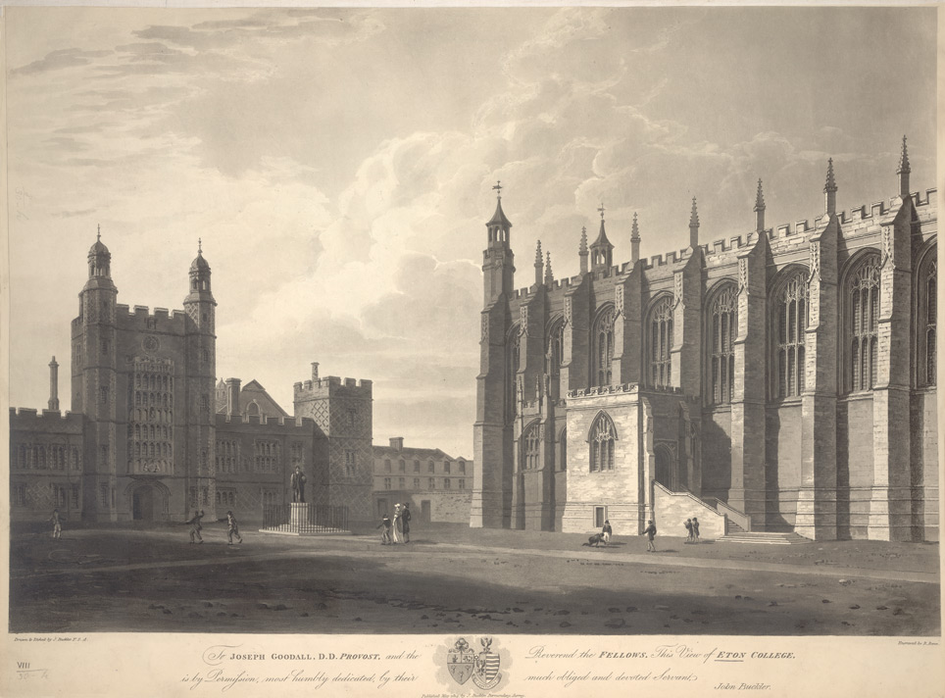

Oxbridge
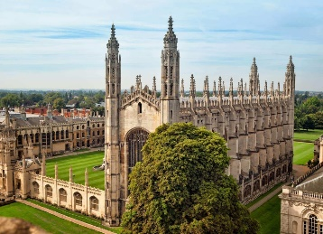
Oxford and Cambridge are the oldest and most prestigious universities in Britain. Known together as “Oxbridge” (the word was invented by Lewis Carroll, the author of ‘Alice in Wonderland’ and a lecturer in mathematics at Oxford), they have been chosen as national icons.

1. Oxford is the oldest university in Britain. Nobody knows exactly when it was founded but teaching was already going on there by the early 12th century. Life was hard at Oxford at that time because of constant trouble between the townspeople and the students. Then one day a student accidentally killed a man of the town. The Major arrested three other students who were innocent, and by order of King John they were hanged. In protest, many students and teachers left Oxford and settled in another little town, and so the University of Cambridge was born. Since then there has been constant friendly (and sometimes not-so-friendly) rivalry between Oxford and Cambridge.

2. Oxbridge is made up of independent colleges. The ‘University’ is just an administrative body that organizes lectures, arranges exams, gives degrees, etc. Today, there are 70 colleges at Oxbridge, and each college has its name, its coat of arms and its own buildings, including a chapel, a library, a dining hall and rooms for students to live in. Each college has its own character and its own traditions. As well as the college libraries, there are two university libraries. They have the right to have a free copy of every book published in Britain.

3. Each Oxbridge college has its own staff, known as “Fellows”. The fellows teach the students either one-to-one or in a very small groups. This system of teaching is one of the ways in which Oxford and Cambridge differ from other universities.
Students also go to lectures that are arranged by the university and are open to all students.
The normal length of the degree course is three years, after which the students take the degree of Bachelor. Some courses, such as medicine or languages, may be one or two years longer. The students may work for other degrees, too.

Vocabulary

- Prestigious - престижный
- Was invented by - был придуман
- National icons - национальная икона (символ)
- Exactly - точно
- Townspeople - горожане
- Accidentally - случайно
- Major- мэр
- Innocent - невиновный
- Were hanged - были повешены
- Settled - заселить
- Rivalry-соперничество, конкуренция
- Made up of independent colleges- состоит из независимых колледжей
- Coat of arms- герб
- Chapel - часовня
- Free copy - бесплатная копия
- Staff - сотрудники
- One-to-one - один на один
- Are arranged by the university- назначенные университетом
- Bachelor - бакалавр (ученая степень)

- Choose the best headings for each part of the story. One heading is extra.

A. History
B. Teaching system
C. Lots and lots of colleges
D. Student’s life

2. Choose True or False

- Oxford and Cambridge are ancient universities in Britain.
- Oxbridge is the oldest Bridge in Oxford.
- Oxford was founded before Cambridge.
- Cambridge is situated inside the town of Oxford.
- The students who killed a man of the town were arrested and executed (казнены).
- Oxbridge has a lot of independent colleges.
- Each college can’t have its name.
- «Fellows» are people who work at a college.
- System of teaching in Oxford and Cambridge is different from other universities.
- Length of the degree course can be three, four or five years.

3. Answer the questions

1) Who invented the word “Oxbridge” for the two English universities?
2) How was the University of Cambridge born?
3) What does every college of the university have?
4) What is the difference in teaching system of Oxbridge and other British universities?
5) How many years do the students at Oxbridge have to study to be given the Bachelor's Degree?
4. Complete these sentences with the information from the text.

- Lewis Carroll was ___________________________________________
- Oxford is___________________________________________________
- Cambridge was founded by_____________________________________
- Oxbridge consists of __________________________________________
- Each college has _____________________________________________

Bonfire Night or Guy Fawkes Day

“Remember, remember The Fifth of November…”

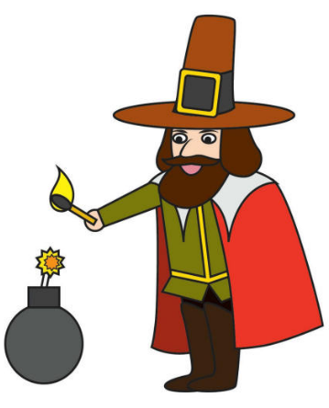
Bonfire Night or Guy Fawkes Day is one of the most popular festivals in Great Britain. It commemorates the discovery of the co-called Gunpowder Plot and is widely celebrated throughout the country. Some days before the fifth of November boys and girls get an old suit or maybe an old pair of dad’s pants and an old jacket and stuff them with straw or newspapers to make a figure. If they can get a hat, they put it on its head too. The scarecrow is called a Guy.
Then the children go with their Guy through the streets asking people for money: “A penny for the Guy, mister?” If they collect enough money, they buy fireworks.
On the fifth of November, as soon as it gets dark, everyone, children and adults, make a huge bonfire and burn the scarecrow on it.
Who was Guy Fawkes? Why do British people still remember this name?
On the fifth of November, 1605 Guy Fawkes tried to blow up the Houses of Parliament. In 1605, King James I was on the throne. He was a Protestant and hated Catholics. James took the Scottish throne when he was just a year old and was known as James VI of Scotland. When Elizabeth I died, he took the English throne as well as the Scottish one. He was the first monarch to rule both countries but he was known as James I of England. Catholics hated him. James had ordered all Catholic priests to leave the country.
Guy Fawkes and some of his friends decided to kill the King and the Members of the Parliament who were making life difficult for Catholics.
To carry out their plan, the plotters got 36 barrels of gunpowder and rolled them into the cellar, just under the House of Lords. The idea was to blow up the gunpowder as soon as the King opened the new session of Parliament on the fifth of November, 1605.
But it became clear that some innocent people would be hurt or killed in the attack. One of the plotters sent an anonymous letter warning his friend, Lord Monteagle, to stay away from the Parliament on the fifth of November. The warning letter was given to the King. The plot was discovered.
In the early hours of the fifth of November, Guy Fawkes, who was hiding in the cellar with the 36 barrels of gunpowder, was arrested and taken to the Tower of London. He was guilty of treason and was executed on January 31st, 1606 in the Old Palace Yard at Westminster.
Every year on fifth of November, Guy Fawkes is remembered. Throughout the country huge bonfires are made, fireworks are set off, people eat special food (toffee apples and jacket potatoes), and a scarecrow of Guy Fawkes is burnt on the bonfire. It is to celebrate the failure of the Gunpowder Plot.
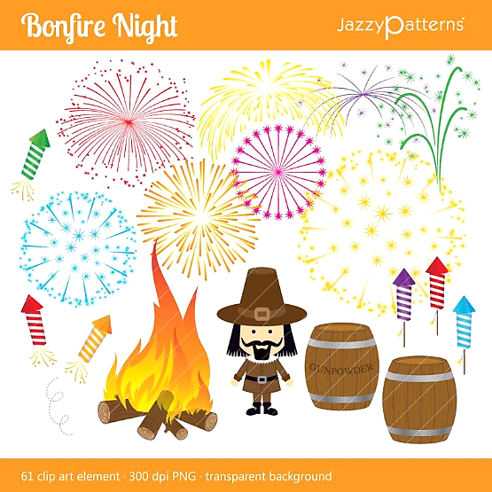
Remember, remember
The Fifth of November,
The Gunpowder treason and plot.
I see no reason why Gunpowder treason should ever be forgot.
Vocabulary
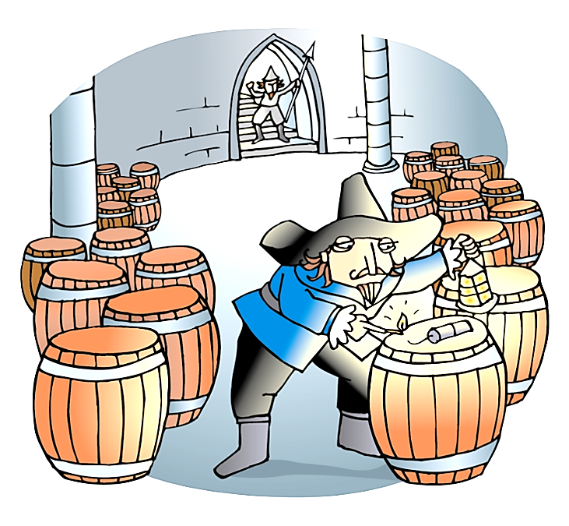
- To commemorate – ознаменовать
- Co-called – так называемый
- Gunpowder - порох
- Plot - заговор
- To stuff – набивать, наполнять
- To blow up – взорвать
- Priest – священник
- To carry out – осуществить
- Plotter – заговорщик
- Barrel – бочка
- Cellar – подвал
- Innocent – невинный
- To warn – предупредить
- To be guilty – быть виновным
- Treason – государственная измена
- To be executed – быть казненным
- Failure – крах, неудачная попытка

- Write the word under the picture.
toffee apple bonfire Guy Fawkes jacket potato firework The Tower of London
King James I The Houses of Parliament
1. | 2. | 3. | 4.
 |  |  | 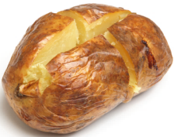
5. | 6. | 7. | 8.

- Match the words with the definitions.
- November | - a large fire made outside to burn unwanted things or for pleasure
- night | - the crime against your country
- firework | - explosive powder used in guns
- bonfire | - a large potato that is baked with its skin on
- plot | - the place where the laws are made
- barrel | - an underground room
- gunpowder | - an apple covered with a sweet substance made from sugar and water, and held on a stick
- cellar | - a person who secretly plans to do something wrong
- parliament | - an object that explodes and produces bright coloured lights
- blow up | - dark hours after evening
- plotter | - a round container made of wood and metal
- treason | - the eleventh month of the year
- toffee apple | - destroy by explosion
- jacket potato | - a secret plan

1 | 2 | 3 | 4 | 5 | 6 | 7 | 8 | 9 | 10 | 11 | 12 | 13 | 14

- Complete the texts with the words.
Gunpowder blow up November Fawkes king plot prison barrels cellar Parliament
bonfire toffee apples fifth Guy jacket potatoes firework celebration food hat garden

London – 1605 (Protestant England)
Guy Fawkes was a Catholic. He hated the king James I and the Parliament because they were anti-Catholic. That is why he wanted to 1)____________ the Houses of 2)_______________. He was not successful. The 3)___________ found out about the 4)_______________ because one of the plotters told his brother-in-law: ‘Don’t go to the Parliament on 5)____________ 5th’. The king’s soldiers caught Guy 6)_____________ with 36 7)___________of 8)__________ in the 9)____________. He was guilty of treason. They put him in 10)___________ and he was sentenced to death.
London – Nowadays
Bonfire Night is perhaps the biggest outdoor 11)____________ in Britain on the 12)___________ of November. People make a figure of 13) ______________, dress it in old clothes and put a 14)___________ on its head. In the evening, they burn this figure on the top of a 15)_______________. Every town and village put on an amazing 16)____________ display. People gather to watch the fireworks and eat traditional Guy Fawkes Night 17)__________. 18)__________ and 19)_________ are the most popular treats. Many families have smaller celebrations and private fireworks displays in their 20)_____________.

- Match the questions about Guy Fawkes to the correct answer to each question.
Guy Fawkes wasn't the leader of the Gunpowder Plot. Write the letter of each answer under the correct number. You can find the name of the leader of the Gunpowder Plot.
1. Is this a story from the nineteenth century? | E. Yes, they do.
2. Were Guy Fawkes and his friends Protestants? | T. Yes, he did.
3. Were there religious problems between the Catholics and the Protestants? | B. Yes, there were.
4. Was there a law saying that Catholics weren't allowed to go to church? | B. Yes. they are.
5. Did Guy Fawkes and his friends decide to kill King James? | E. Yes, there was.
6. Did Guy Fawkes put gunpowder in the Houses of Parliament? | R. Yes, they did.
7. Was the date the 11th of December 1605? | R. No, it isn't. It's a story from the seventeenth century.
8. Did the plan succeed? | A. No, it didn't. The king's soldiers discovered the plan.
9. Did the king forgive Guy Fawkes? | O. No, they weren't. They were Catholics.
10. Do British people celebrate Guy Fawkes’ Night with bonfires and fireworks? | T. No, he didn't. He decided to kill Guy Fawkes and his friends.
11. Do children make models of King James and burn them on the bonfires? | Y. No, they aren't. Toffee apples and jacket potatoes are popular.
12. Are the models called ‘guys’? | C. No, it wasn't. It was the 5th of November 1605.
13. Are ice-cream and salad popular on Bonfire Night? | S. No, they don't. They make models of Guy Fawkes.
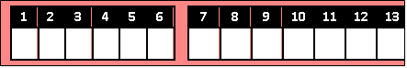

- Answer the questions.

- Who was on the throne in 1605?
- Why did the plotters want to kill the king?
- What did the plotters want to blow up?
- How many barrels of gunpowder did the plotters have?
- Where did the plotters hide the barrels with gunpowder?
- When did the plotters want to blow up the Houses of Parliament?
- How was the plot discovered?
- When did Guy Fawkes die?
- What does Bonfire Night commemorate?
- How do British people celebrate Guy Fawkes Day nowadays?
- What is traditional food for this festival?
- Would you like to take part in this festival? Why?

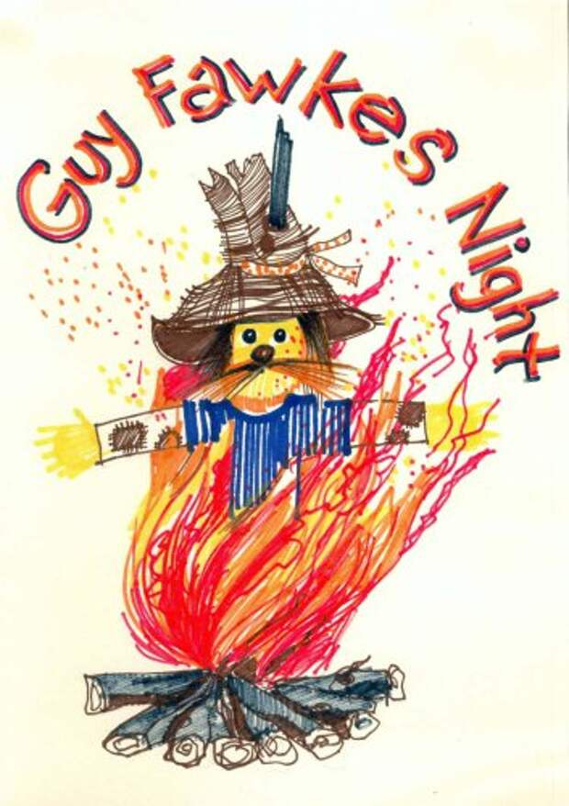

Christmas Down Under
Christmas in Australia is not like anywhere else! Everything is topsy-turvy because December is one of the hottest months of the year. Anyway, the Australians have a great time. Those who live near the coast go to the beach on Christmas day. They have a swim, play cricket or volleyball, surf or just sit around with family and friends enjoying Christmas dinner. Santa Claus arrives at Australian beaches on a surfboard - quite a change from sliding down a chimney!
He often wears a swimsuit or funny baggy shorts as the weather is hot.
Christmas is a great time for kids and students - it's the beginning of their summer holidays and this means FUN, SUN and SURF!
Many Christmas decorations and symbols are the same as in Great Britain or the USA: Christmas trees (usually plastic), Dickensian images of turkeys and plum puddings, snow scenes ... But among the decorations you can also see toy kangaroos and koala bears stifling in Santa hats or red scarves! And instead of holly and mistletoe the Australians often use local plants - Christmas bush and Christmas bell.
As with Christmas anywhere, families have their own traditions. In spite of the heat many Australians still have traditional hot Christmas meal. It usually includes roast turkey and a flaming Christmas pudding with a tasty sauce. Others prefer a more sensible meal of seafood or cold ham, turkey and salads. Ice cream Christmas pudding (vanilla ice-cream with nuts and fruit and choc bits) is one way round the traditions. One unique and excellent Australian dessert is the Pavlova - a light cake made of meringue, cream and fruit. (They say it was invented to celebrate the Russian ballerina Anna Pavlova's visit to Australia.)
Australia is also the home of Carols by Candlelight, a tradition started by Norman Banks, a radio announcer, in 1937. One day Banks saw a lonely woman listening to a Christmas carol by candlelight. He decided to do something to relieve the loneliness some people felt during the holidays.
Today, Carols by Candlelight is held each Christmas Eve and involves tens of thousands of people. They spread blankets on the ground, light their candles and sing Christmas songs together. The view is amazing with thousands of candles waving in the dark!

Vоcabulary

1. Down Under - Австралия (или страна, где все ходят вниз головой) | 15. Include - включать, содержать
2. Topsy-Turvy – перевёрнутый, вверх тормашками | 16. Roast – жареный; жарить
3. Coast - морской берег | 17. Flaming - горящий
4. Slide down – соскальзывать, скатиться | 18. Sauce - соус
5. Chimney – труба, дымоход | 19. Sensible - разумный
6. Dickensian images – дикенсовские образы, изображения | 20. Seafood - морепродукты
7. Turkey - индейка | 21. Unique - уникальный
8. Plum pudding – сливовый пудинг | 22. Meringue - безе
9. Stifle - задыхаться | 23. Carols by Candlelight - рождественские песни при свечах
10. Holly – падуб, остролист (вечнозеленое растение с красными ягодами, рождественское украшение) | 24. Radio announcer - диктор
11. Mistletoe - омела белая (вечнозеленое растение, рождественское украшение) | 25. Relieve - облегчать
12. Bush - куст, кустарник | 26. Involve - вовлекать, привлекать к участию
13. In spite of - несмотря на | 27. Blanket - шерстяное одеяло
14. Heat - жара | 28. Waving – колеблющийся
  - Fill in the gaps with the words from the box.
sauce heat mistletoe coast sensible bush blankets includes

- Others prefer a more ______________ meal of seafood or cold ham, turkey and salads.
- And instead of holly and __________the Australians often use local plants - Christmas __________and Christmas bell.
- They spread ____________on the ground, light their candles and sing Christmas songs together.
- Those who live near the ___________go to the beach on Christmas day.
- In spite of the __________ many Australians still have traditional hot Christmas meal.
- It usually ______________roast turkey and a flaming Christmas pudding with a tasty_________.
- Fill in the correct prepositions.
- December is one ____the hottest months ____the year.
- Those who live near the coast go _____the beach ____ Christmas day.
- Santa Claus arrives ____Australian beaches ____a surfboard.
- Christmas is a great time _____ kids and students.
- Many Christmas decorations and symbols are the same as ____Great Britain or the USA.
- But _________the decorations you can also see toy kangaroos and koala bears in Santa hats or red scarves.
- And _____________holly and mistletoe the Australians often use local plants - Christmas bush and Christmas bell.
- _____________the heat many Australians still have traditional hot Christmas meal.
- One day Banks saw a lonely woman listening ______a Christmas carol ______candlelight.
- They spread blankets _______the ground, light their candles and sing Christmas songs together.

- Answer the questions and retell the story.
- What is December like in Australia?
- Where do people go on Christmas day?
- What do they do?
- How does Santa Claus arrive at Australian beaches?
- What does he wear?
- Why is Christmas a great time for children and students?
- What are Christmas decorations like?
- What plants do the Australians often use instead of holly and mistletoe?
11. What kind of meal do many Australians have?
12. What can you tell about the tradition Carols by Candlelight?

- Complete the crossword.

 |  |  |  |  |  |  |  |  |  |  | ³ |  |  | ⁶ |  |  |  | ¹⁰
 |  |  |  | ²
 |  |  |  |  |  |  |  |  |  |  |  |  |  |  |  | ¹³
 |  |  |  |  |  |  | ⁵
 |  |  |  |  |  |  |  |  |  |  |  |  | ¹²
¹ |  |  |  |  | ⁴
 |  |  |  |  |  |  |  |  |  |  |  |  | ¹⁶
 |  |  |  |  |  |  |  |  | ¹¹
 |  |  |  |  |  |  | ⁷ |  |  |  | ¹⁵
 |  |  |  |  | ⁸ |  |  |  |  |  |  |  | ¹⁷ |  | ¹⁸ |  |  |  |  |  |  | ²⁰
 |  |  |  |  |  |  | ¹⁴
 |  |  | ⁹ |  |  |  |  |  |  |  |  |  |  |  | ¹⁹

Across:  1. декабрь  2. свет горящей свечи  5. морской берег  7. разумный  9. морепродукты  12. безе | 13. уникальный  16. соус  17. индейка  19. Австралия | Down:  3. Рождество  4. куст, кустарник  5. рождественские песни  6. жара  8. шерстяное одеяло  10. пудинг | 11. включать, содержать  12. омела белая  14. падуб, остролист  15. вовлекать, привлекать к участию  18. жареный; жарить  20. труба, дымоход

DIWALI
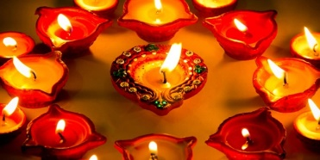
India is a country in South Asia. It is the second most populous country in the world with a population of more than 1.4 billion people. The capital is New Delhi.
India is a unique country with a thousand years of history and culture. Homeland to the ancient Indus Valley Civilization and four religions Hinduism, Buddhism, Jainism, and Sikhism are originally from India. One of the most colorful and happiest festival Diwali takes part in India every autumn.
Diwali is the most important religious festival celebrated by followers of Hinduism. It is also referred to as Deepavali or Deepawali or the Festival of Lights. The Festival of Lights celebrates the Hindu New Year and the victory of light over darkness and the triumph of good over evil.
This festival celebrates the Hindu New Year and festivities can last up to five days. Diwali takes place every year in late October or early November depending on the cycle of the moon. The festival starts two days before the new moon comes up.
The name Deepavali originates from the ancient Indian Sanskrit language and means 'row of lights'. 'Dipa' means 'Light' and ' avali' is the word for ‘row’.
There are various legends that refer to the festival. They traditionally involve the Hindu gods Rama, Lakshmi or Krishna. They all celebrate the victory of the good over the evil and this festival is a celebration of hope, happiness and peace.
Originally Diwali was celebrated as a harvest festival in India, but today Diwali is celebrated as the festival of light by Hindus all over the world. This festival is celebrated with sparklers, firecrackers and fireworks are held in many places.
At Diwali it is tradition to decorate and illuminate homes, visit the local temple for prayers and share meals with families and friends. Children get small gifts and sweets. Traditional Diwali food includes sweets such as the delicious syrupy gulab jamun balls and other Indian sweets displayed below.
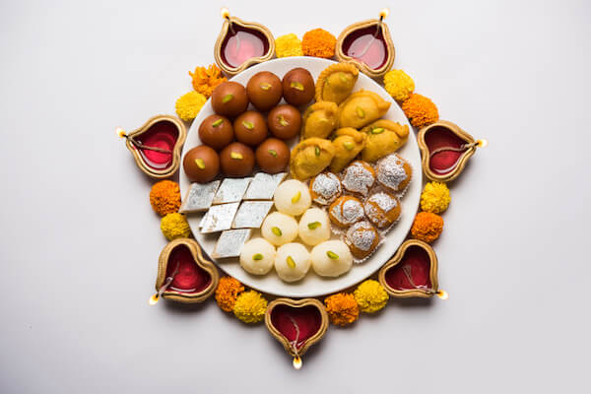
Lighting candles, oil lamps and sparklers are the main customs at this festival. Indians light diyas which are candleholders or clay lamps that are used for decoration. Homes and buildings are also decorated with rangoli decorations made with flowers, colored sand or even colored rice, flour or spices. Statues of Lakshmi, the four-armed Hindu goddess of prosperity, and of Ganesha, the Hindu lord of success usually referred to as the 'Elephant God', are also cherished and decorated with flowers in many homes. Larger Diwali celebrations outside India take place in Singapore's Little India district as well as in London and Leicester/UK, Sydney/Australia and Toronto/Canada where some main roads are decorated with lights and the Hindu community gathers and showcases Indian traditions, crafts and Indian food at fairs and festival grounds.
Sikhs, Jains and Buddhists also celebrate the new year with a festival of light on these dates but have different legends and traditions referring to the event.
Vocabulary
- Refer to - означать 10. Gulab jamun - индийский десерт
- Row of lights -ряды огней 11. Clay - глина
- Harvest festival- праздник урожая 12. Rangoli - индийский орнамент
- Temple- храм 13. Showcase - демонстрация, показ
- Prayer - молитва 14. Fair - ярмарка

1.Fill the gaps with prepositions.
- India is the country_____ South Asia.
- Diwali is the most important religious festival celebrated _____ followers of Hinduism.
- This festival celebrates the Hindu New Year and festivities can last _____ _____ five days.
- This festival is celebrated _____ sparklers, firecrackers and fireworks are held in many places.
- At Diwali it is tradition to decorate and illuminate the homes, visit the local temple _____
- prayers and share meals with families and friends.
- Lighting candles, oil lamps and sparklers are the main customs _____ this festival.

2.Read the descriptions and find the words in the text.
fair harvest follower darkness sparkles temple ancient prosperity craft population custom

1. All the inhabitant of a particular area, country, place.
2. Someone who has a great interest in something.
3.The total absence of light
4. Belonging to the very distant past and no longer in existence
5. The process or period of gathering in crops.
6. A lot of small points of light.
7. A building devoted to the worship of a god or gods.
8. A way of behaving or a belief that has been established for a long time.
9. The state of being successful and having a lot of money.
10. An activity involving skill in making things by hand.
11.A large public event where goods are bought and sold, and where there is often entertainment.

3.Complete the gaps with the correct form of the words in the left.
1. Diwali is the most important _____ festival | RELIGION
2. Diwali is the most important religious festival celebrates the victory of light over _____ | DARK
3. This festival celebrates the Hindu New Year and ______ can last up to five days | FESTIVAL
4. They _____ involve the Hindu gods Rama, Lakshmi or Krishna | TRADITION
5.This festival is a celebration of hope, ______and peace. | HAPPY
6.Lakshmi is the four-armed Hindu ______ of prosperity | GOD

- Match
 | South | a | lamps
2 | Unique | b | Asia
3 | Colorful | c | language
4 | Ancient | d | lamps
5 | Various | e | country
6 | Harvest | f | legends
7 | Clay | g | festival

5. Answer the questions
1. Where is India situated?
2. What is the population of India?
3. What is Diwali?
4. What does this festival celebrate?
5. When does Diwali take place?
6. When does the name Diwali originate from?
7. What is this festival celebrated with?
8. What do people do at Diwali?
9. What are the maim customs of the festival?
10.Where does this festival take place outside India?

6. Retell the text.

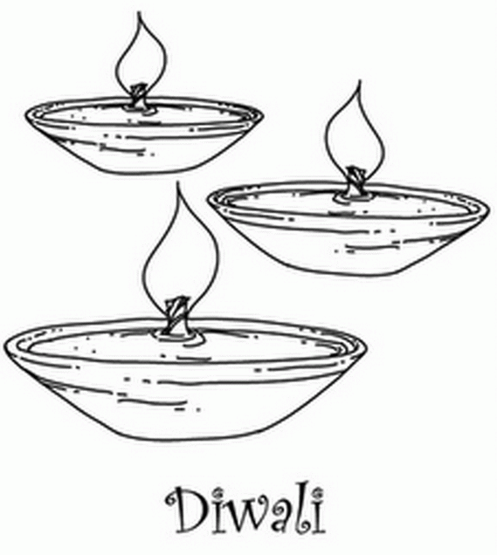

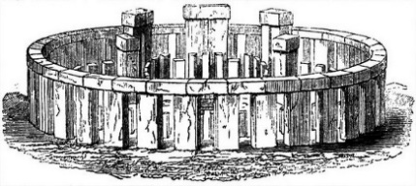
Stonehenge
What is Stonehenge?
Stonehenge is a prehistoric monument located in Wiltshire, England. One of the most famous sites in the world, Stonehenge is the remains of a ring of standing stones that is between 4,000 and 5,000 years old. Stonehenge is a huge man-made circle of standing stones. Built by our ancestors over many hundreds of years, it’s one of the world’s most famous prehistoric monuments… And one of its biggest mysteries, too!

When was Stonehenge built?
Work started on this super stone circle around 5,000 years ago in the late Neolithic Age – but it took over 1,000 years to build, in four long stages! Archaeologists believe the final changes were made around 1,500BC, in the early Bronze Age.
4,000 years ago, Stonehenge was made up of an outer circle of 30 standing stones called ‘sarsens’, which surrounded five huge stone arches in a horseshoe shape. There were also two circles made of smaller ‘bluestones’ – one inside the outer circle and one inside the horseshoe – as well as four stones positioned outside the central monument.

How was Stonehenge built?
It’s the question that has baffled people for centuries – and even to this day there is no proved theory! How could people thousands of years ago have transported and arranged such colossal stones? There are 83 stones at Stonehenge and two different types of stone are used.
A legend from the 12th century tells us that giants placed the monument on a mountain in Ireland, before a wizard named Merlin magically moved the stone circle to England. It’s a shame they didn’t really have a wizard to help them – they could have done with the help…
The lighter bluestones weigh about 3,600kg each (that’s the same as two cars!), while the bigger stones each weigh 22 tons – that’s as heavy as four African elephants! But how were these huge stones lifted to their standing position? Well, it’s thought that at first, the builders dug deep ditches for the base of the boulders. They then used ropes and strong wooden poles and frames to raise them up. And voilà – job done!

What was Stonehenge used for?
Once again, no one really knows for sure. There are many different theories… Each year, on 21 June (the longest day of the year), the sun always rises over the Heel Stone at Stonehenge – a single large sarsen stone which stands outside of the main monument. And the sun always sets over the Heel Stone on the shortest day of the year. Therefore, researchers believe that Stonehenge may have been a ‘calendar’, linked to the study of the stars.
Other theories suggest that the site could have been a place of healing where sick people came in hope of being cured by the monument’s miraculous powers. Others think the site may have been a kind of Stone Age ‘computer’ or a temple to the sun or moon gods.
But one thing is for sure – Stonehenge was used as a cemetery. They say that about 200 people are buried on the grounds. They also think that important funeral ceremonies would have been performed at the site – though why the dead were laid to rest there, no one knows…

Vocabulary

1. Remains – остатки (останки) 11. Man-made – сделан человеком
2. Ancestors – предки 12. Prehistoric – доисторический
3. Neolithic Age – эпоха неолита 13. Arches - арки
4. Bronze Age – бронзовый век 14. Horseshoe – подкова
5. Baffled- сбит с толку 15. Ireland – Ирландия
6. Merlin – британский мифический
волшебник времён короля Артура 16. Dug deep ditches – глубоко
7. Boulders - валуны вырытые канавы/ров
8. Heel Stone – «пяточный» камень 17. Healing – исцеление
9. Temple – храм 18. Used – использовался
10. Cemetery – кладбище 19. Funeral ceremonies – похоронные церемонии

- Answer the questions.
- What is Stonehenge?
- When was Stonehenge built?
- How was Stonehenge built?
- Where is Stonehenge located?
- What was Stonehenge used for?
- Where does the Sun always rise at Stonehenge?
- Where does the Sun always set?
- What theories about Stonehenge do you remember?

- Match the words with the definitions.

monument | very big
circle | ideas intended to explain something
stone | A place where dead people are buried
huge | something which was built in memory of some famous people or events
theory | a round shape figure
cemetery | a very hard naturally made mineral/rock

- Complete the gaps with the correct form of the words in the left.

- It’s one of the world’s most ____________ prehistoric monuments. | FAME
- There were also two circles made of ____________ ‘bluestones’ | SMALL
- There are 83 stones at Stonehenge and two __________types of stone are used. | DIFFER
- …before a wizard named Merlin __________ moved the stone circle to England | MAGIC
- But how were these huge stones ____________ to their standing position? | LIFT
- And the sun always sets over the Heel Stone on the ___________ day of the year. | SHORT
- …where sick people came in hope of being cured by the monument’s _______________ powers. | MIRACLE

- Read the sentence. Circle the correct variant.
- One of the most famous sites in the world, Stonehenge is the remains of a ring of standing stones that is between ________ and ________ years old.
♦ 4.000 – 5.000 ♦ 3.000 - 6.000 ♦ 4.000 - 7.000
- Work started on this super stone circle around 5,000 years ago in the late ___________.
♦ Bronze Age ♦ Neolithic Age ♦ Iron Age
- There are ______ stones at Stonehenge and two different types of stone are used.
♦ 84 ♦ 83 ♦ 100
- The lighter bluestones weigh about 3,600kg each (that’s the same as two cars!)
♦ 3,600 ♦ 2,600 ♦ 5,600

The Giant’s Causeway and the Legend of Finn McCool
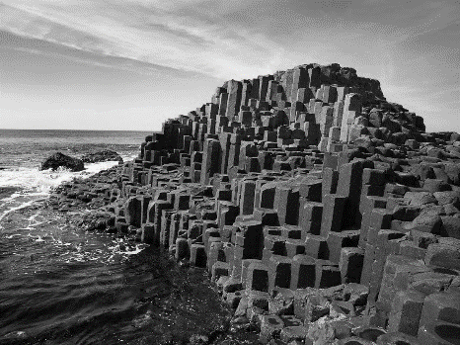
On the north-east coast of Northern Ireland, you can see a mass of unusually shaped rocks. Scientists say that they were formed by a flow of lava into the sea about 60-65 million years ago. The area consists of about 40.000 hexagonal basalt columns. But when these amazing rocks were discovered in the late 17th century, it wasn’t known whether they were formed by men with tools or naturally. So another theory went round, too – that they were the work of the giant called Finn McCool.
The story goes that Finn McCool was extremely strong. One day he was going about his daily duties when one of his enemies, a Scottish giant Fingal, started teasing him and shouting at him from across the channel.
This annoyed Finn, so he lifted a huge piece of earth and threw it at the Scottish giant.
Fingal picked up a rock, threw it back at Finn and shouted, “You’re lucky there’s water between us. I’m not a strong swimmer, otherwise I’d beat you up!”
Finn was furious and began lifting huge pieces of earth from the shore, throwing them so as to make a crossing for the Scottish giant. When he had finished, he shouted, “Now you have no excuse. Come and face me!”
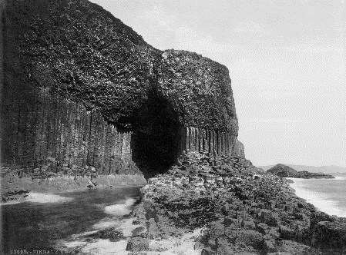
However, Finn McCool was extremely tired. He needed to rest before he fought the Scottish giant. So he decided to make a large cot, disguised himself as a baby, got inside and waited.
When Fingal came into his house and saw the baby, he couldn’t believe his eyes. “If the son is so huge, what size is his father? “With this thought, Fingal turned away and ran back, in terror, to Scotland, destroying the causeway as he went. He left in such a hurry that his boot came off and it is still there today. Fingal fled to a cave on the island of Staffa which is – to this day – called “Fingal’s Cave.”

Vocabulary
- Giant’s Causeway – Тропа великана
- Flow of lava – поток лавы
- Hexagonal –шестиугольный
- Basalt –базальт, базальтовый
- Tool – инструмент
- Extremely – очень, чрезвычайно
- Daily duties – ежедневные обязанности
- Enemy – враг
- Co tease – дразнить
- Channel – пролив
- To annoy – раздражать, сердить
- Otherwise – иначе, а то
- Furious – взбешённый, в ярости
- Excuse – предлог, отговорка, оправдание
- Cot – детская кроватка
- To disguise – изменять внешность, маскироваться
- In terror – в ужасе
- To destroy – разрушать
- To flee (fled) – убегать, спасаться бегством
- Cave – пещера
- Staffa – Стаффа (остров на западе Шотландии)

- What’s the word? Write the word under the pictures.

scientist flow of lava coast tools cot island rocks cave

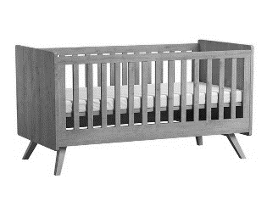 | 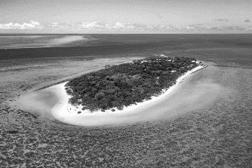 | 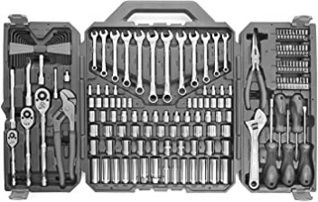 | 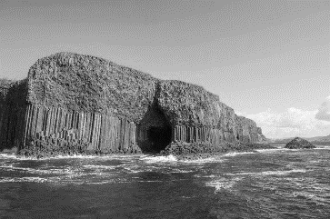
 | 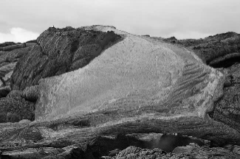 | 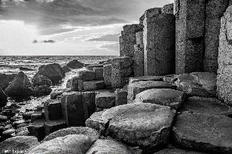 | 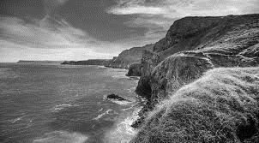

- Match the words with the definitions.

to discover | to make someone angry
to tease | to think that something is true, correct or real
to annoy | to damage something so badly that it cannot be used
to believe | to find information, a place, or an object, especially for the first time
to lift | to escape by running away, especially because of danger or fear
to destroy | to give a new appearance to a person or thing, especially in order to hide its true form
to flee | to laugh at someone or say unkind things about them, either because you are joking or because you want to upset that person
to disguise | to move something from a lower to a higher position

- Complete the gaps with the correct form of the words in the left.

- ___________ Ireland is famous for its Giant’s Causeway. | NORTH
- On the north- east coast you can see a mass of _____________ shaped rocks. | USUALLY
- ______________ say that they were formed by a flow of lava into the sea. | SCIENCE
- These _____________ rocks were discovered in the 17th century. | AMAZE
- No one knew if the rocks were formed by men with tool or ______________. | NATURE
- The giant was _________________ strong. | EXTREME
- One of his enemies was a __________________ giant named Fingal. | SCOTLAND
- Finn was ___________ and began lifting huge pieces of earth from the shore. | FURY

- Fill in the gaps with prepositions.
- ____the late 17th century
- to be formed _____someone
- to go _________the daily duties
- to shout _____someone
- to pick _____a rock
- to come ________the house
- to beat someone _____
- to leave _____ a hurry

- Read the sentence. Circle the correct answer.
- The area consists of about 40.000 _____________ basalt columns.
- pentagonal/ hexagonal/ quadrangular
- The Giant’s Causeway was discovered ________________ 17th century.
- in the early/ in the late/ in the middle of the
- One day Finn McCool was going about his daily duties when one of his ____________
started teasing him.
- enemies/friends/neighbors
- When Fingal came into Finn’s house he saw ___________________.
- an old man/ a baby/ a young lady
- There is a cave on the island of Staffa which is called “________________”.
- Finn’s cave/ Fingal’s cave/ McCool’s cave

- Put the sentences in the right order, then retell the legend of Finn McCool.

- However, Finn McCool was extremely tired and needed to rest before he fought the Scottish giant.
- When Fingal came into Finn’s house he was in terror.
- The story goes that Finn McCool was extremely strong.
- Finn was annoyed and threw a huge piece of earth at the Scottish giant.
- Fingal left in such a hurry that his boot came off.
- One day he was going about his daily duties when a Scottish giant Fingal started teasing and shouting at him from across the channel.
- Finn made a large cot, disguised himself as a baby, got inside and waited.
- Fingal fled to a cave on the island of Staffa.
- When Finn found out that Fingal wasn’t a strong swimmer he made a crossing for him.
- When Fingal saw a huge boy he turned away and ran back to Scotland.

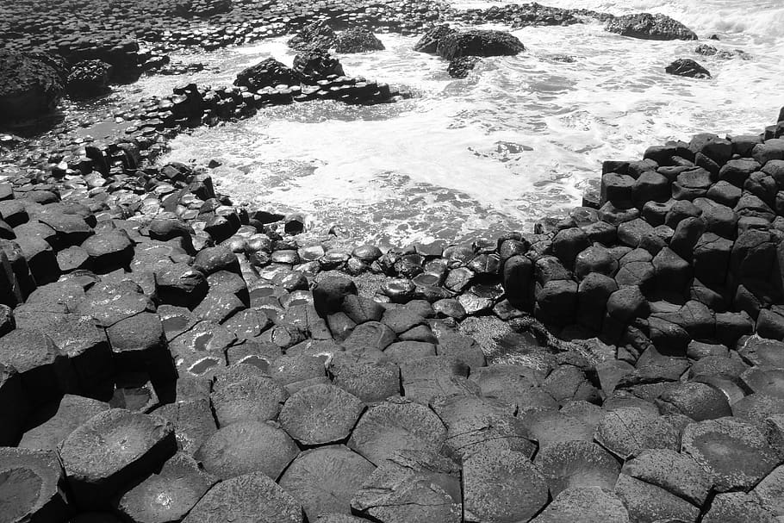

New Zealand
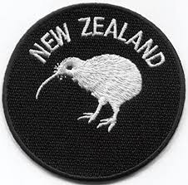
New Zealand is a very interesting country. It has got total area of 269,000 square kilometers. It is situated to south-east of Australia in the Pacific Ocean. It consists of two main islands (North Island and South Island) and some smaller ones. Nearly 3.5 million people live in the country. The capital of New Zealand is Wellington. It is a financial centre too. The city was founded in 1840 and has been the capital since 1865. The official language is English.
The climate of New Zealand is moist. New Zealand is rich in minerals. There are some main industries in the country, for example, iron and steel industry. But the main industry in New Zealand is agriculture, especially cattle farming, marine fishing, fruit production. New Zealand exports wool, meat, butter.
There are many mountains in New Zealand. The highest is Mount Cook (3,764 metres or 12,349 feet). The North Island is long and volcanic in its south central part. New Zealand has many springs and geysers. There are many rivers, waterfalls and lakes in the country. The main rivers are the Waikato and the Wairu. New Zealand has more than 50 volcanoes, some are still active today. Snowy peaks, rocky shores, and pastures create a really majestic landscape.
Because of its long isolation from the rest of the world, New Zealand has extraordinary flora and fauna. About 80% of the flora in New Zealand occurs only in New Zealand. The varied landscape of New Zealand has made it a popular location for the production of television programs and films, including ‘The Lord of the Rings’ and ‘The Last Samurai”.

You have heard about the native animals in the country. One of them is the kiwi bird. This interesting bird lives in the wet parts of the thick bushes. In the day-time the bird does not go out. It comes out only at night to find food. Kiwis cannot fly. Many years ago kiwis were hunted for food. Now the government does not permit the hunting the kiwis. The kiwi is now the symbol of New Zealand people. Small children are often called kiwis.
The first settlers of New Zealand were Maoris. The Maori named New Zealand Aotearoa, which is usually translated into English as ‘The Land of the Long White Cloud’. The Dutch cartographers called the islands Nova Zealandia, after the Dutch province of Zeeland. In 1769, Captain James Cook came to the islands. The British established settlements and signed a treaty with the Maori in 1840.

Nowadays New Zealand is an independent state, but formally it is a part of the British Commonwealth of Nations. The head of the state is the British Queen. New Zealand is self-governing state. The Prime Minister is the head of the government.

There are some big cities such as Auckland, Wellington, Christchurch, Dunedin, Nelson. Auckland and Wellington are the main ports of the country.

New Zealand is a very unusual and beautiful country.

Vocabulary
- Area – Территория
- Was Founded — Был Основан
- Moist - Влажный
- Industry - Промышленность
- Iron And Steel — Железо И Сталь
- Cattle — Домашний Скот
- Springs - Источники
- Waterfalls - Водопады
- Peaks - Вершины
- Rocky Shores — Горные Вершины
- British Commonwealth of Nations – Британское Содружество Наций
- Majestic - Величественные
- To Occur - Случаться
- Bushes - Кусты
- Government - Правительство
- Settlers - Поселенцы
- Cartographers - Картографы
- Independent - Независимый
- Self-Governing — Самоуправляемый
- Native - Природный/Родной

1. Read the sentences. Choose the correct answer.

1) It is situated to south-east of Australia in the …………..Ocean.
a) Indian b) Pacific c) Atlantic

2) The capital of New Zealand is ……………...
a) Washington b) Wellington c) Abington

3) In the ……………... the bird does not go out.
a) night-time b) mornings c) day-time

4) Many years ago kiwis were …………….. for food.
a) hunted b) shoot c) fought

5) The head of the state is the………………...
a) American President b) British Prime Minister c) British Queen

6) But the main industry in New Zealand is ………………..., especially cattle farming, marine fishing, fruit production.
a) fishing b) agriculture c) tourism

- Match the words with the definitions

1.waterfall | a) free from outside control
2.government | b) the process of making products by using machinery and factories
3. independent | c) to make something possible
4.industry | d) system of social control of the society
5.to permit | e) an area where water flows over a vertical drop

3. Match the words from two columns and make collocations.

1.active | a) fishing
2.marine | b) shores
3.independent | c) volcano
4.rocky | d) production
5.fruit | e) state

4. Complete the sentences with the collocations from the ex.3

1. Inside an ……………………, the air is hot and full of toxic gases.
2. Thailand is famous for its ……………………. It has been focused in the Northern regions. Some of them are exotic – Durian, Mangosteen, Rambutan and Lychee.
3. ………………….have been studied for a long time for ecology and biological processes.
4. The USA became an……………………….on July 4th, 1776.
5. The ……………………… is a great part of the country trade’s incomes.

5. Guess the word!

1. k - - -i
2. m - - - - - - n
3. g - - - -r
4. i - - - - - - y
5. w - - - - - - - l

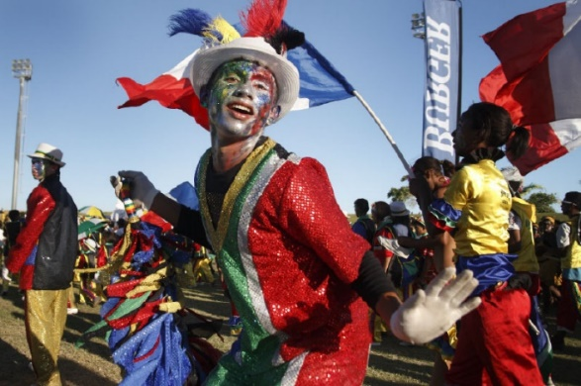
The History of the Cape Town Minstrel Carnival
The Cape Town Minstrel Carnival, known as Second New Year, is a colourful parade in Cape Town. It’s a lively event popular with all locals in and is considered a must-see for all visitors.
On the 2nd of January musicians, performers and families from all walks of life take to the streets in bright uniforms to sing, dance, and play music for the crowds as they parade.
This parade is a cultural tradition that dates back to the early years of colonization in Cape Town. Slaves were brought to Cape Town from all corners of the globe. Many of these people could not speak the same language and had little in common. However, the New Year was a time of the year when all people united and celebrated together.
It was a time for a lot of festivities and happiness, and by mingling with the colonists and foreign traders from around the world, the laborers created their own dances, songs, music and even languages.
Everyone dressed in colourful attire, traditionally with a tailcoat, a bow tie, a top hat. This same style can be seen today, but with blazers instead of tailcoats. They traditionally play jazz instruments and play classical or cultural music passed down through generations, or play popular songs from the year.
Over the years, after slavery was abolished, the community continued performing in the streets, taking pride in the tradition that gave them joy and hope in the darkest years of their history.
This tradition was passed down for years and even became a form of competition where Minstrel troupes used to compete to be the best performers. But this was less important than the self-expression and the entertainment. Nowadays, visitors are welcome to join in the parade and are bound to have a great deal of fun.
Vocabulary

- Minstrel – менестрель (певец, музыкант)
- Lively – яркий, оживленный
- A must see – обязательно для просмотра
- Walks of life – слои общества
- To take to the streets – выходить на улицы
- To date back to – восходить, уходить корнями
- A slave – раб, невольник
- The globe – мир
- Festivity – веселье, празднование
- To mingle – смешиваться, общаться
- A trader – торговец
- A labourer – труженик
- Attire – наряд, костюм
- A tailcoat – фрак
- A generation - поколение
- Abolish – отменять
- Take pride in – гордиться
- Pass down – передавать
- Self-expression – самовыражение
- Be bound to – обязательно

- Do the crossword. Use the words from the text.

1
2

3

4

5

6

7

8

9

  - Someone who entertains people
  - Full of energy and interest
  - Tell somebody e.g. a story in order they keep it
  - An item of formal clothes that has a short front part and a long back
  - To mix or to meet and talk to a lot of people
  - Someone who is under control of another person
  - A travelling musician and singer
  - To feel very pleased about something you are closely connected with
  - Great happiness
THE KEY WORD IS _________

- Complete the sentences with the words from the text in the correct form.
  - The tradition to put presents into stockings d____ b___ to the life of Saint Nicholas.
  - Musicians at concerts of classical music are usually dressed in t________.
  - The New Year celebration is a l_____ and vibrant event.
  - Tourists from all over the g____ visit this festival.
  - The tournament turned into a real f_______ for all children and their parents.
  - Red Square and the Kremlin are a definitely m______.
  - Lots of citizens t___ __ ___ s______ to see fireworks.
  - Spectators ___ b____ to love this performance!

- Use the words in capitals to form a new word that fits into each blank.
- The Olympic Games are a unique sports and cultural ____________ that promotes the values we wish to cherish in our global village.  - The art of jewelry is a form of ____________.  - Every ____________ requires a reminder that our world is fragile.  - ____________ cultivate land and harvest crops.  - They cooperate with ____________ from Germany.  - What a ! All spectators are thrilled!  - It was one of the most ____________ shows that has ever been in this circus.  - You can take ____________ that you have done all tasks correctly. | FESTIVE  EXPRESS  GENERATE  LABOUR  TRADE  PERFORM  COLOUR  PROUD
- Make the questions so that they fit the answers.
  - ________________________________________________?
A colourful parade in Cape Town.
  - ________________________________________________?
On the 2nd of January.
  - ________________________________________________?
It dates back to the early years of colonization in Cape Town.
  - ________________________________________________?
Dances, songs, music and even languages.
  - ________________________________________________?
Colourful attire with a tailcoat, a bow tie and a top hat.
  - ________________________________________________?
Jazz instruments, classical or cultural music, popular songs.
  - ________________________________________________?
A form of competition.
  - ________________________________________________?
The self-expression and the entertainment.

- Give a talk on the Cape Town Minstrel Carnival. Cover the following points:
- a general description of the carnival,
- the date of celebration,
- the history of the event,
- the clothes people wear,
- the activities people do,
- the significance of the event for Cape Town citizens.

СПИСОК ИСПОЛЬЗОВАННЫХ ИСТОЧНИКОВ И ЛИТЕРАТУРЫ

- Павлоцкий В.М., British studies. - Издательство "Базис" ИПЦ "Каро", СПб, 2000.
- Diwali 2020: what is Diwali? URL: https://www.almanac.com/content/diwali
- Eton URL: teacherhelp.ru
- Журнал для изучающих английский язык “Speak Out”, №98-99, 2013. – Изд. Глосса-Пресс, Москва. С.12-13
- National Geographic Kids URL: natgeokids.com/uk/general-history/Stonehenge-facts/

Учебное пособие
СБОРНИК ТЕКСТОВ ДЛЯ ДОМАШНЕГО ЧТЕНИЯ
(английский язык, 6 класс)
на английском языке

Авторы-составители: З.В.Зимина, М.В.Криволесова, М.М.Хорева, И.М.Куликова, Н.З.Кутепова, Е.Д.Лаевская, А.В.Малиновская, Н.С.Маталина, Е.Д.Таликина, И.Г.Назарова, О.М.Рыкова, Е.А.Райтер, А.В.Сулимова

Дизайн, верстка: М.М.Хорева, Куликова И.М.

Подписано в печать – 30.03.2021
Тираж – 260 экземпляров

197136, Санкт-Петербург, Чкаловский пр. 35
Тел. (812) 346-00-87, факс 346-00-86

