Иващенко Виктория Дмитриевна,
учитель английского языка МБОУ «Гимназия №7» города Мурманска,
г. Мурманск
Технологическая карта урока по учебному предмету «Английский язык» в 7-ом классе на тему «The evolution of gadgets and devices»
Тип урока: |  |  | Урок развивающего контроля. Урок-проект
Авторы УМК: |  |  | «Английский в фокусе» Ваулина Ю.Е., Дули Дж. и др.
Цели урока: |  |  | Деятельностная: научить детей способам взаимоконтроля, формировать способности, позволяющие осуществлять контроль; развивать навыки проектной деятельности.  Содержательная: проверка умения чтения с извлечением запрашиваемой информации.
Технология обучения: |  |  | Проектная деятельность
Планируемые образовательные результаты:
Предметные | Метапредметные |  |  | Личностные
- строить связное монологическое высказывание с опорой на ключевые слова, план, вопросы в рамках освоенной тематики;  - кратко излагать результаты выполненной проектной работы;  - делать краткие выписки из текста с целью их использования в собственных устных высказываниях. | - систематизировать, сопоставлять, анализировать, обобщать и интерпретировать информацию, содержащуюся в готовых информационных объектах;  - выделять главную и избыточную информацию, выполнять смысловое свертывание выделенных фактов, мыслей; представлять информацию в наглядно-символической форме (в виде таблицы)  - заполнять и дополнять схемы. |  |  | - формирование коммуникативной компетентности в общении и сотрудничестве со сверстниками, старшими и младшими в образовательной, учебно-исследовательской деятельности;  - освоение социальных норм, правил поведения, ролей и форм социальной жизни в группах и сообществах, формирование основ социально-критического мышления.
Оборудование: |  | Мультимедийная презентация на этапе целеполагания  Дидактические материалы на этапе реализации и презентации проекта
Образовательные ресурсы: |  | Иллюстративный материал (www.youtube.com)  Раздаточный материал (приложения)

Этап урока | Задача | Деятельность учителя | Деятельность учащихся
Целеполагание | Обсуждение проблемы, целей, задач конечного продукта | Good morning! I hope you are feeling good today.  At the beginning of our lesson, I would like you to watch a short video film to answer a question.  Teacher’s question: What are we going to talk about? (Can we name them in one word?)  What other words do you know to describe these things?  There are more words to describe these things: inventions, instruments, appliances, tools. Have a look at the blackboard.  We can’t live without modern devices and gadgets.  Everybody knows how these inventions look now. Do you know how the first phones or computers looked? Can we imagine how they will look in the future?  Let’s write a message to future generation and compare past, present and future devices.  This is the aim of our lesson. | Students listen to the teacher and watch a video.  Then they answer the question and name some devices.  Gadgets, devices, machines, equipment…
Планирование | Организовать деятельность по проекту | What should we do to write this message?  Do you have any ideas?  Name 4 -5-action verbs to name our steps.  For example, read…  Make up word combinations with verbs and nouns.  For example, read a text…  Put them in the correct order to make a plan of our work.  Firstly…  Secondly…  Now we shall do some group work. Divide into three groups. We are going to have a leader, a designer, a collector in every group.  Here are some instructions for you. (Приложение №4) | Read, collect, find, draw, present.  Find information, collect information, draw pictures, present a message  1. Read the text  2. Find information  3. Collect information  4. Glue and draw pictures  5. Create a message  6. Present a message  Form three groups; choose a leader, a designer, a collector.  Read instructions, follow them.
Реализация проекта | Выполнение плана | You have 20 min to do this task.  Помощь в организации работы групп.  Приложения №1-3 | Read the text.  The leaders organize the group work and introduce a project.  The collectors mark the text and collect the information.  The designers choose the pictures, glue them and draw the image of devices in the future.  Приложение №6.
Презентация проекта |  | If you are ready, we’ll begin. Each group should present the class its message. Приложение №5.  The task is to choose the most interesting presentation while listening. What is the best presentation to your mind? Collectors, tell me, please, your marks to each group.  The…group has made the best presentation. | The leaders introduce a project.  The leaders with the rest of the group give marks to the presentations.  (Приложение №7 – оценочные листы)  The collectors put down their marks.
Анализ | Оценка и коррекция | The teacher analyses the typical mistakes. (That’s a pity, there were some typical mistakes in your presentations. Firstly, be careful with your phonetics and grammar. For example,….)  So, we are ready to send these messages to future students of our school. We leave the tube in our school museum.

Приложение №1 (текст для группы №1).
We can’t imagine our life without mobile phones. If you had been told several years ago that mobile phones would become so helpful and smart, you would not have believed that!
In the late 40's Swedish inventors Styure Laurenu and Ragnar Berglund created the first mobile phone. These early car based mobile phones were used only to call someone. They were operated as a walkie-talkie, with only one person being able to speak at a time, and you had to push a button each time you wished to talk - known as a push-to-talk phone. The weight of this first mobile phone was around 34kg, so it's no wonder they were left in cars!
Today, the iPhone 7+ is an iconic phone for users, although our choice of smartphones has never been greater. Development of the iPhone began in 2004 in the USA, California, when Apple started to gather a team of 1,000 creators, including Jonathan Ive, the designer and Steve Jobs who steered the original focus away from a tablet. According to Steve Jobs, the "i" word in "iMac" (and therefore "iPod", "iPhone" and "iPad") stands for internet, individual, instruct, inform and inspire. All modern models look alike. They are flat and touch-sensitive; they are completed with a good camera and gigs of memory. Nowadays, we use these devices not only to call or write someone. We take photos, read books, watch films, play games and do many other things as well.

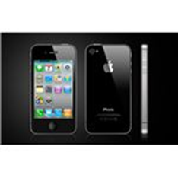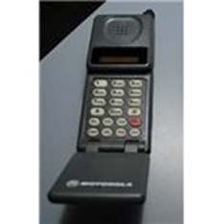

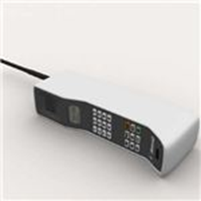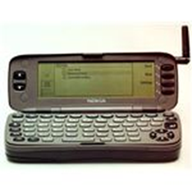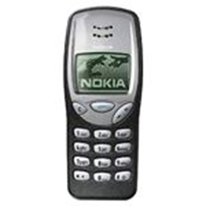

Приложение №2 (текст для группы №2).
Computers
We use computers almost every day. We use computers at school and work. We have computers in our cell phones and in our cars. Most young children learn how to use computers very early. They have toys that include a computer, and young children learn how to use tablets made for kids.
This has not always been the case. There was a time when there were no computers! Let's take a look at the history of computers. In 1822, in England Charles Babbage invented a calculating machine that could perform mathematical calculations using steam power. In 1890, Herman Hollerith created a punch card system that helps the US government calculate the results of the census. His company would eventually become IBM, which still makes computers today. In 1937, John Vincent Atanasoff, a professor of physics and mathematics at Iowa State University, built the first computer without gears or shafts. By 1941, he had helped to build a machine that could store information in its "memory." This machine could also solve 29 equations at the same time!
Computers, though, still were not common in every household. They were large and expensive. In the late 1900s and early 2000s, computer technology advanced. Computers got smaller and cheaper over time. Laptops and tablets have slowly replaced the «desktop» computer. What is amazing is that many people now carry a "computer"-their smart phones-in the palm of their hands.
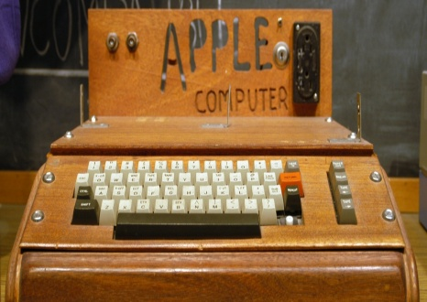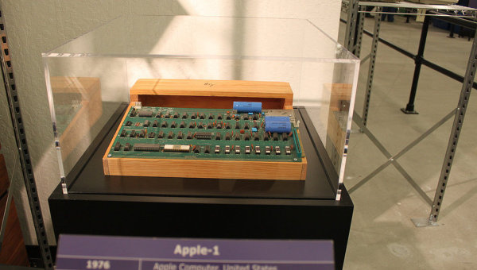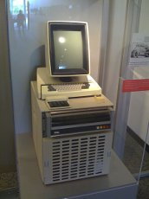
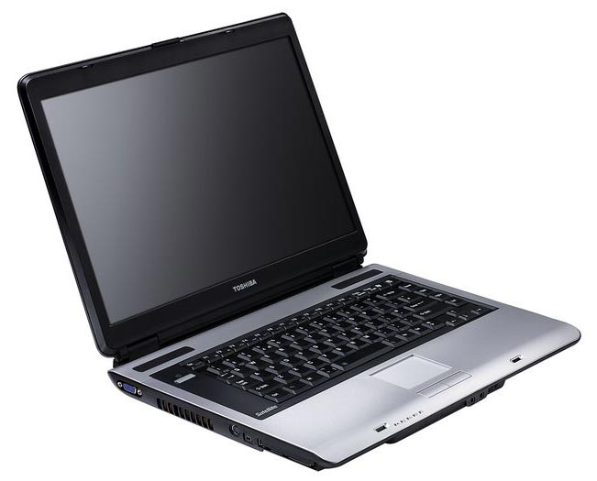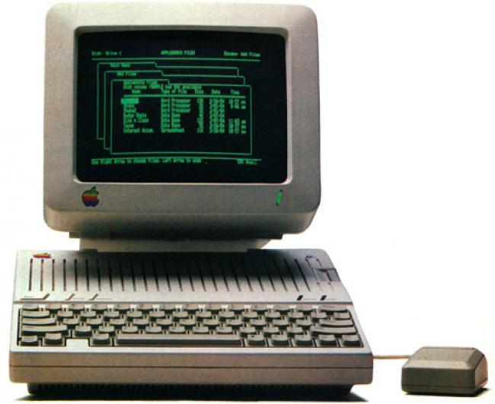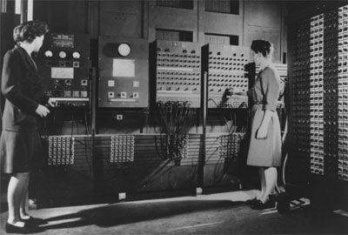

Приложение №3 (текст для группы №3).
In the very beginning, of course, there was the abacus, a sort of hand operated mechanical calculator using beads on rods, first used by Sumerians and Egyptians around 2000 BC.
The first mechanical calculator appeared in 1642, the creations of French intellectual and mathematics whizz kid Blaise Pascal as “a device that will eventually perform all four arithmetic operations without relying on human intelligence.”
That had to wait until 1820 and the patenting in France of Thomas de Colmar’s four function Arithmometer. This first commercially viable counting machine was manufactured from 1851 to 1915 and copied by around 20 companies across Europe. A further step forward occurred in 1887 when Dorr. E. Felt’s US-patented key driven ‘Comptometer’ took calculating into the push button age. This machine, too, spurred a host of imitators.
The Curta calculator was conceived by Curt Herzstark in the 1930s in Vienna, Austria. It was perhaps the ultimate expression of the mechanical calculator, so compact that it could fit into a pocket and capable of addition, subtraction, multiplication and division. Calculators became more advanced in the 1970s. They were portable and they are operated through battery power. The first portable calculators were invented in 1966 by Jerry D. Merryman, James H. Van Tassel and Jack St. Clair Kilby.
Engineering students most probably use the complicated calculators performing various operations today. Using calculators helps you to save time and reduce paper work.
1.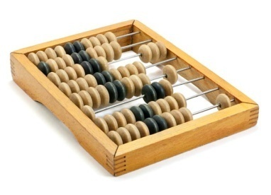 2.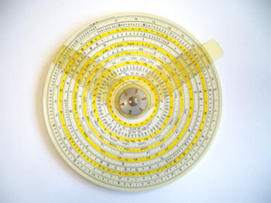 3.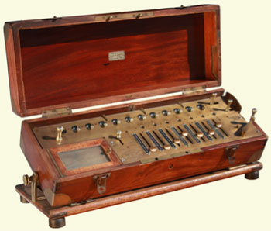 4.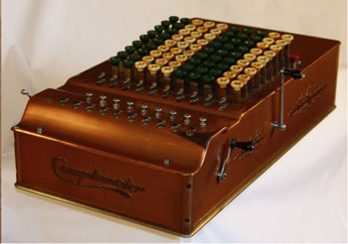 5. 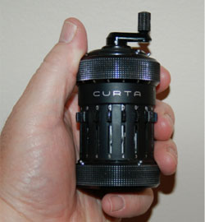6.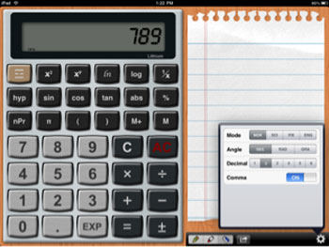

Приложение № 4 (инструкция)
Choose a leader, a designer, a collector in your group.
Their functions:
A leader helps to find the information, introduces the project and gives marks to presentations of other groups.
A designer chooses the pictures, glues them on the page and draws a future device.
A collector finds the information and marks the text.

Приложение № 5 (план ответа)

I'd like to present our message.
Here you can see some pictures of a … in the past, present and future.
The first inventor(s) was (were)… The… was invented in… Firstly, it was …. In the past, people used it for…
The modern gadget is invented by… and in… It looks like… Now, it is used for…
We think the future inventor of a … will be a (an)…designer in 20… It will be…People will use it for…
That is all that I wanted to tell you.

Приложение № 6 (макет сообщения)
The name of the gadget:

Options | In the past | Now | In the future
Presentation | Picture | Picture | Drawing
The inventors

The date of invention

The place of invention

Description

Using

Приложение № 7 (карточка для оценивания презентации)

Plan | № … group | № … group | № … group
1.Полнота и информативность
1. Illustrations
2. The inventor
3. The date of invention
4. The place of invention
5. Description
6. Using
2. Оригинальность
3. Красочность
4. Итого

Баллы для оценивания
1 | 2 | 3
Not very good | Good | Very good

