Project code: AICS 12885/01/0

Summary :
During July, the program expanded its vocational and educational offerings by launching four active skill-building groups and conducting high-impact community outreach. A major achievement this month was the initiative taken by local trainers to develop and deliver an advanced Web Development & Coding module, significantly elevating the center’s technical curriculum. Coordination with key community partners (BCF, PDO, and Marina Organization) remained strong to establish and select candidates for new training groups, while also conducting targeted awareness sessions on digital safety.

# Act. 1.2 Training on basic skills
The training activities for July were distributed across four active groups as follows:
Web Development & Coding Course: This innovative course teaches students how to build websites using HTML, CSS, and JavaScript. The group consists of 10 beneficiaries (3 males, 7 females; aged 18–25), including 2 IDPs and 8 host community members. They have successfully completed 8 sessions to date.
English Language (Pre-Intermediate Level): Focusing on reading, writing, listening, and grammar skills, this course serves 10 beneficiaries (1 male, 9 females), all from the host community. They have completed 7 sessions so far.
Arabic Language Group 1 (Intermediate Level): Focusing on practical speaking and grammar, this group consists of 9 female beneficiaries, all from the host community, aged 18–29. They have completed 6 sessions.
Arabic Language Group 2 (Intermediate Level): Also focusing on intermediate speaking and grammar, this group serves 10 beneficiaries (5 males, 5 females; aged 18–29), including 4 IDPs and 6 host community members. They have completed 6 sessions.

Highlights of the month:

Trainer-Led Technical Innovation: A standout highlight this month was the successful launch of the Web Development & Coding Course. Although advanced digital coding falls outside the standard local trainer mandate, our team proactively developed the curriculum and facilitated the sessions, delivering high-value technical skills to our youth participants.

High Community Demand: Interest in our vocational offerings has reached a record high, with our local trainer waiting list exceeding 100 beneficiaries across various modules.

Targeted Digital Safety Awareness: In partnership with Marina Organization (Sumel Branch), we conducted a specialized awareness session for 20 beneficiaries (aged 8–50). The session focused on the misuse of smartphones and telecommunication devices, their negative impact, and the legal penalties and consequences associated with cyber offenses and device misuse under applicable laws.

Strategic Partnerships & Outreach:

Strategic Partnerships: To coordinate for upcoming training cohorts and register new beneficiaries, and expand project activities, our team conducted field coordination visit to:

1. Barzani Charity Foundation (BCF)
2. Peace and Human Development Organization (PDO)

Challenges and amendments:
Power Supply and Climate Constraints: The primary operational challenge faced this month was frequent power outages during scheduled training hours. Extreme summer temperatures made it difficult to continue classroom sessions without electricity for cooling. Additionally, power interruptions directly impacted the IT and Web Development classes, as desktop computers rely on continuous electrical supply to function.

Lessons Learned

Broad Demand Across All Courses: The growing waiting list of over 100 prospective beneficiaries spans all available training modules, demonstrating a strong overall community demand for the center's educational programs.

Power & Cooling Contingency: Extreme summer temperatures combined with power instability highlighted the need for immediate technical maintenance on the center's split-unit air conditioners. Additionally, sessions must be flexibly rescheduled during power outages or low-voltage periods to ensure a proper learning environment.

Plan for next Month

# | Activities/Output# | due date
1 | Launch of new Employability Skills Course | August 2026
2 | Launch of new Kurdish Language Course | August 2026
3 | Continue remaining sessions for active web development, English, and Arabic groups. | August 2026
5
6
7

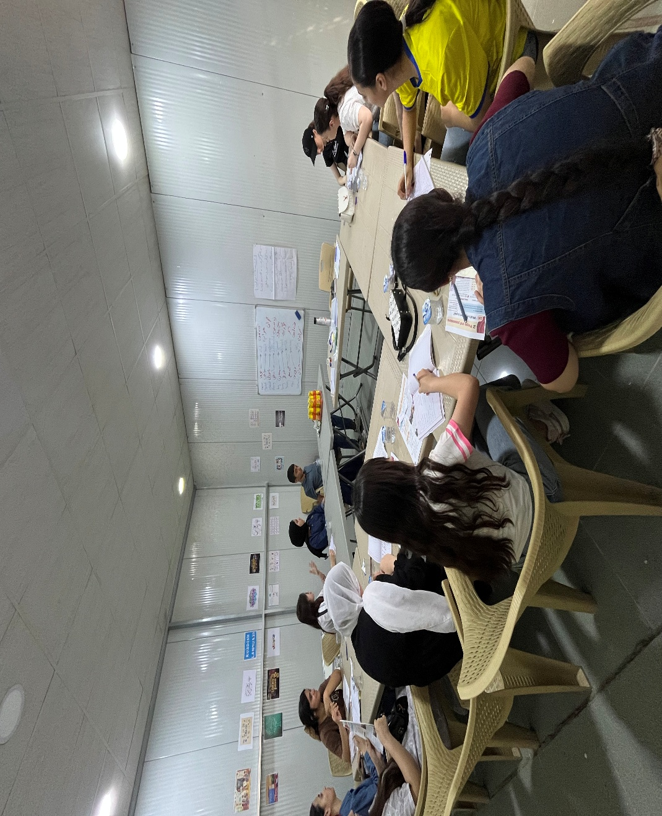
English Language

Arabic Language

Web Development & Coding

Awareness

