СМИ http://lipetsktime.ru/news/society/novosti_chasa_lipetskoe_vremya2037812147824317/
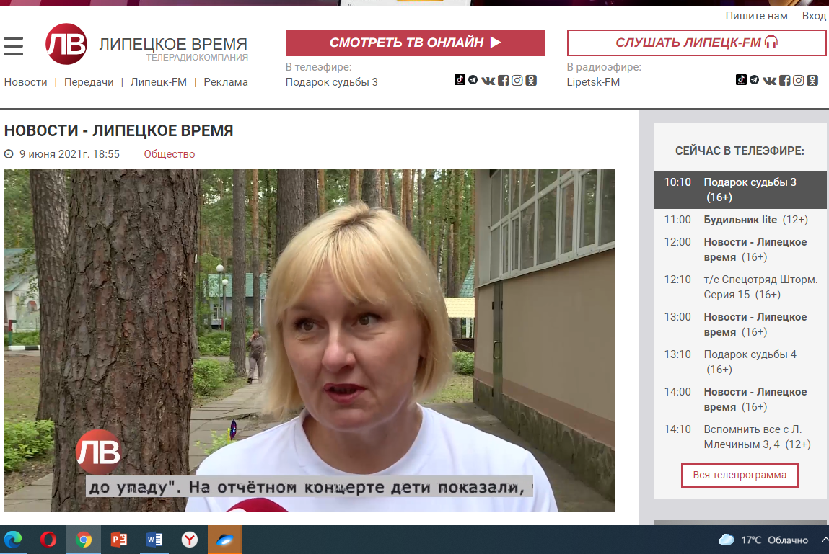

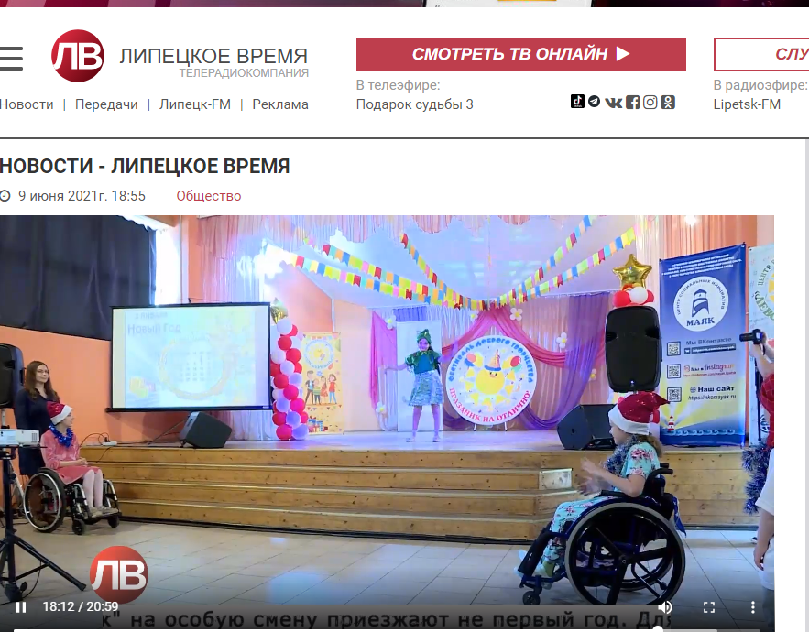

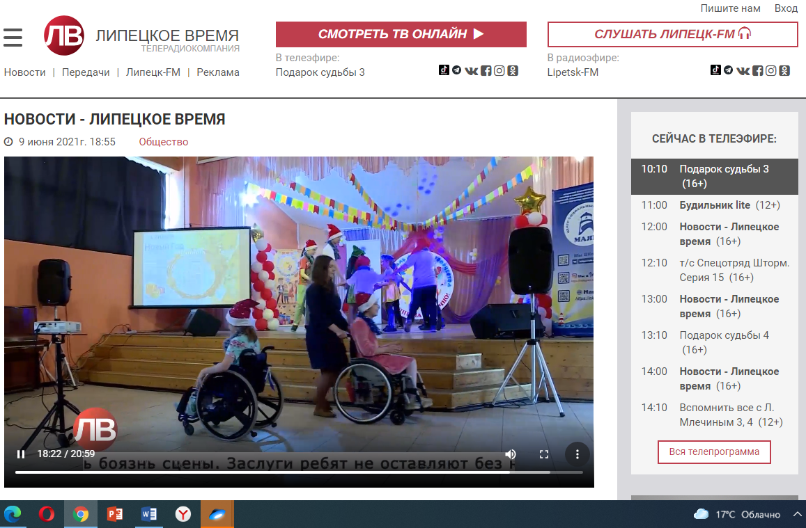

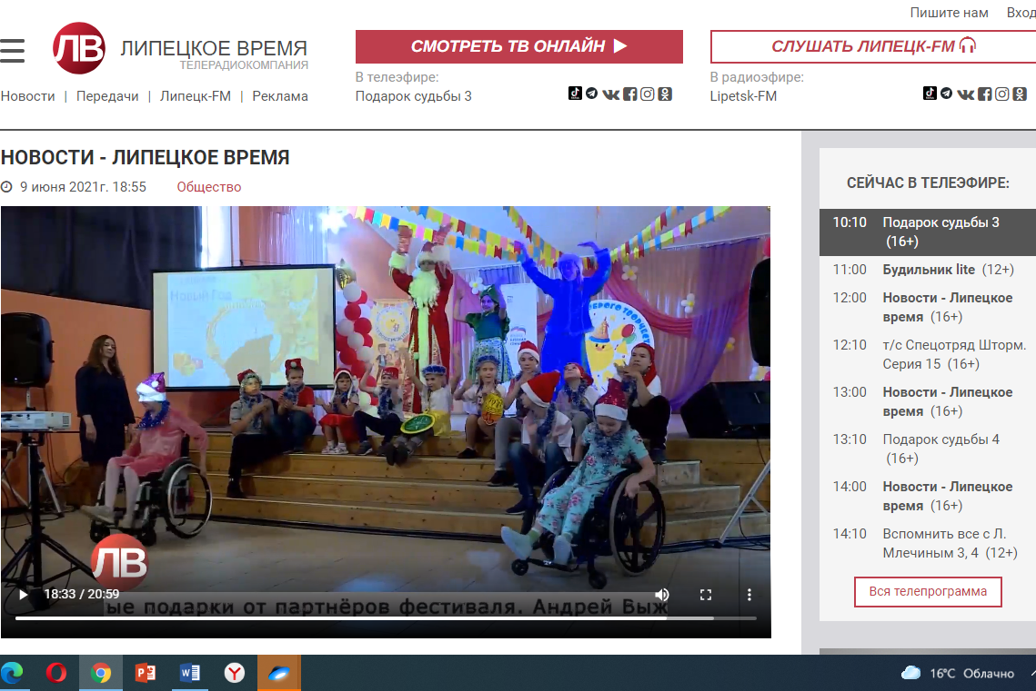

https://nko-maximum.ru/festival-dobrogo-tvorchestva-3-yarkih-tvorcheskih-dnya-dlya-detej-s-ogranichennymi-vozmozhnostyami-zdorovya-ih-roditelej-partnyorov-druzej-i-volonterov/

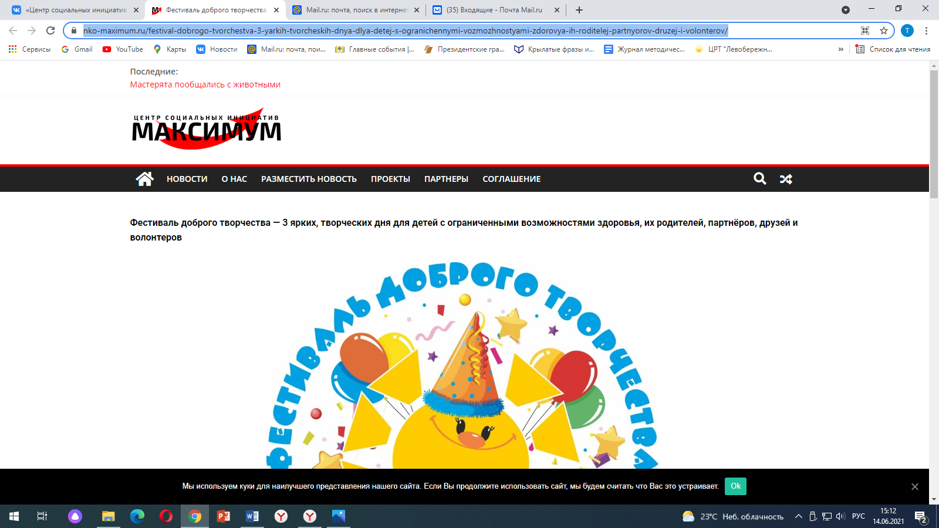

https://vk.com/club124134902?w=wall-124134902_1483

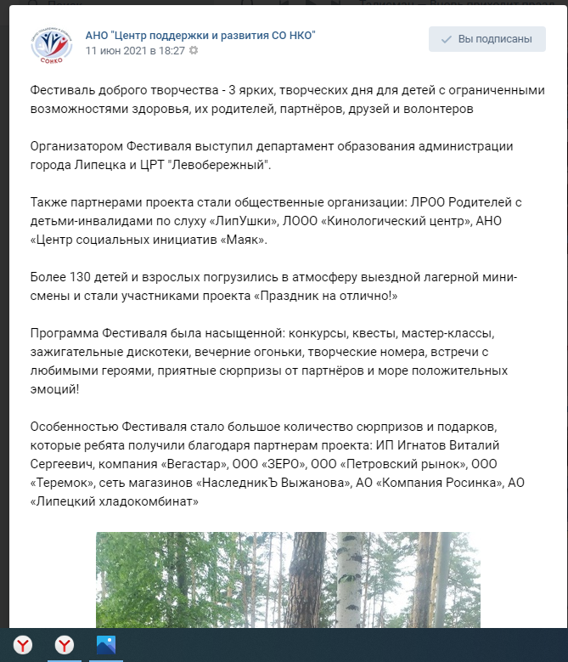
https://zen.yandex.ru/media/id/5b1186ac482677af3cfb0b6d/festival-dobrogo-tvorchestva-3-iarkih-tvorcheskih-dnia-dlia-detei-s-ogranichennymi-vozmojnostiami-zdorovia-ih-roditelei-partnerov-60c37ecde72f9332f7b7a24e

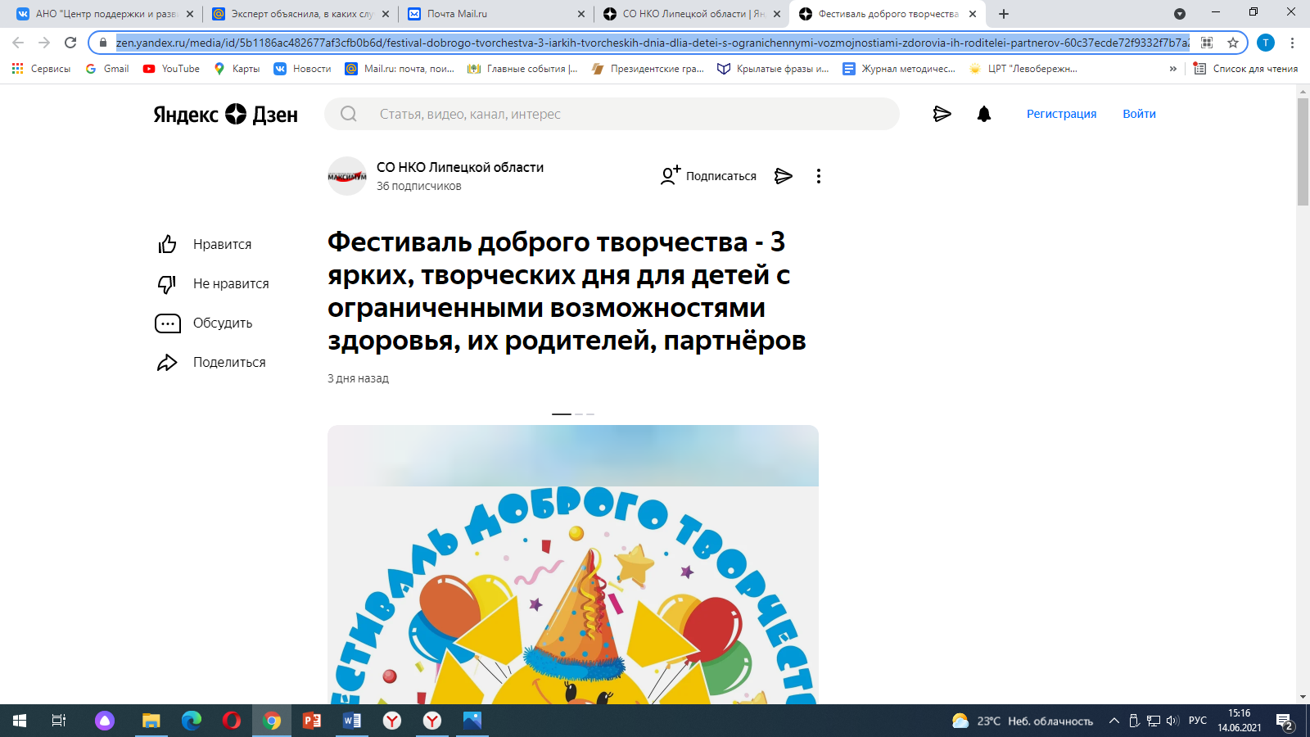

https://sonko-centr.ru/poslednie-novosti/festival-dobrogo-tvorchestva-3-yarkih-tvorcheskih-dnya-dlya-detej-s-ogranichennymi-vozmozhnostyami-zdorovya-ih-roditelej-partnyorov-druzej-i-volonterov/

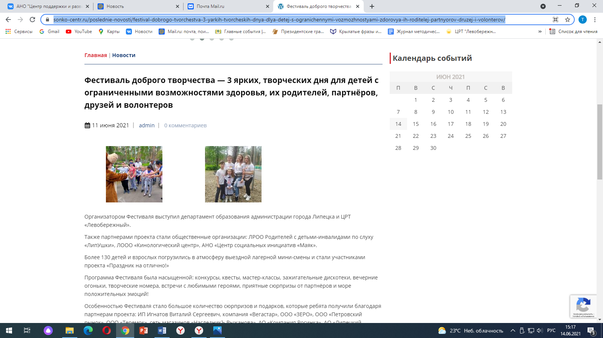

https://vk.com/nko.csim?w=wall-64944218_1509

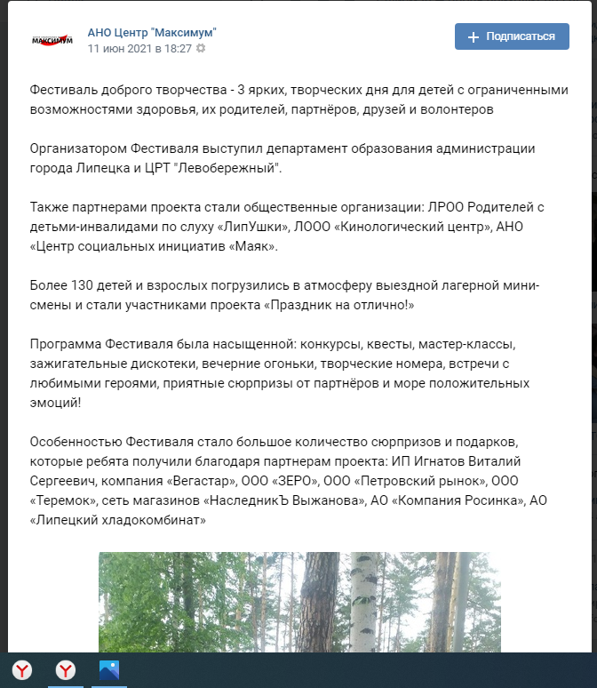

https://www.instagram.com/p/CP_CLfchwad/

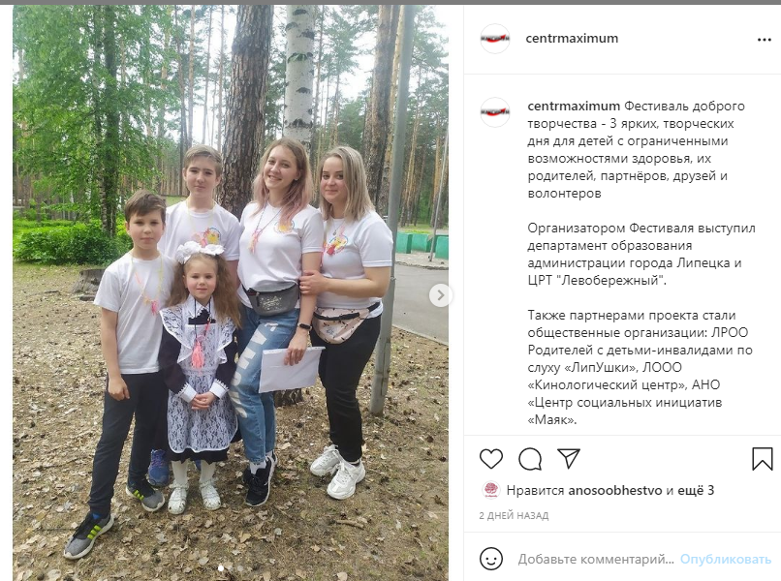

https://www.instagram.com/p/CP_CLa8B6c8/

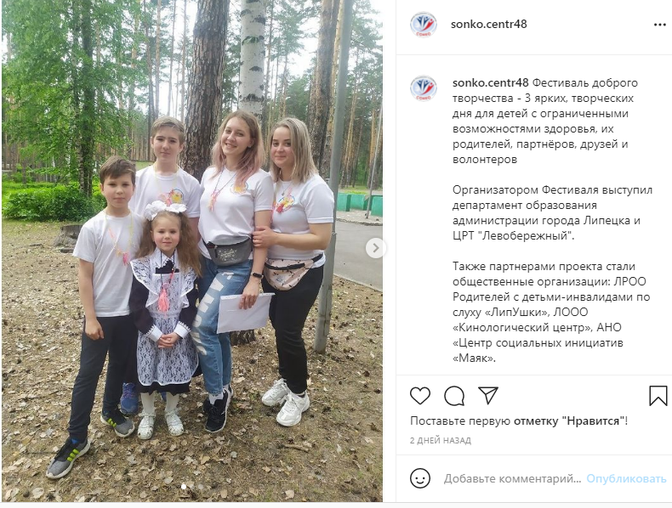

https://www.facebook.com/groups/274852036562541/?ref=nf_target&fref=nf&__xts__[0]=68.ARCicJD_xDsBRnWO9MCdg2zQGSfBOWJ5yU6tYjfwzGN0hgyl3Q_3p34072cFHMpJTPm8FlTVc1CGeqncwYWd5a-RkG1y43wszpvT0ibGd7HVk_T829vMeWoClCKJoI3Z10nwC1UtTLCPI3ah1VAT9oYgWq0fc7eUIVu-AOdXEjeRtmR5dRGF5rRr8Nf3LNJi1IpzgE_GM7liOTjtEu96E39K_RpQDfPO25q_xF6-36zwtnzfb0FtD37Y-r4dl8APN8my04JTL4100rSfgoBH70b4q16o-BZ6

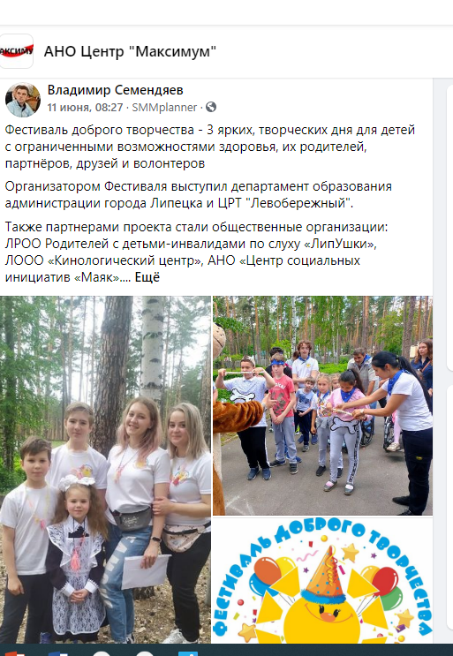

http://www.doal.ru/node/6445

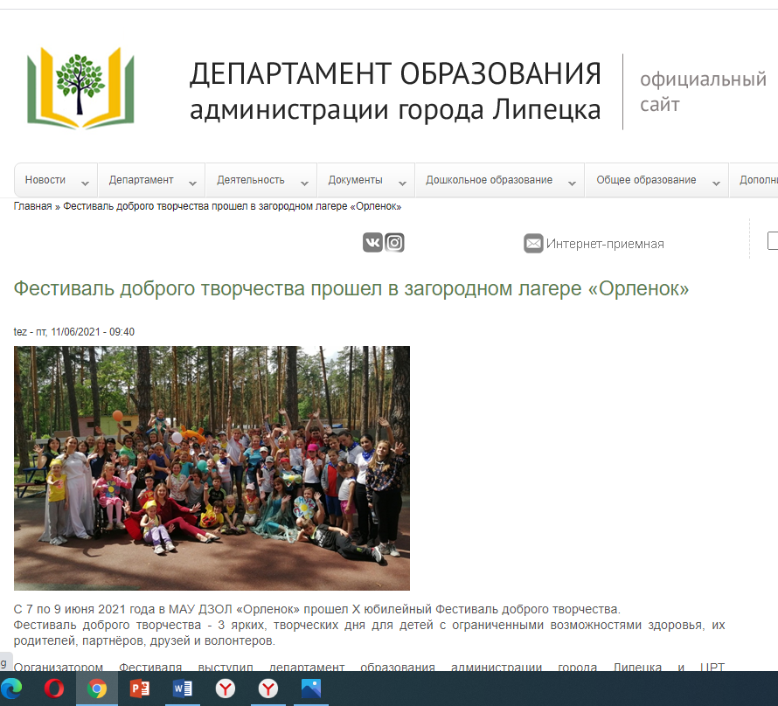

https://vk.com/doal48?w=wall-153497132_6589

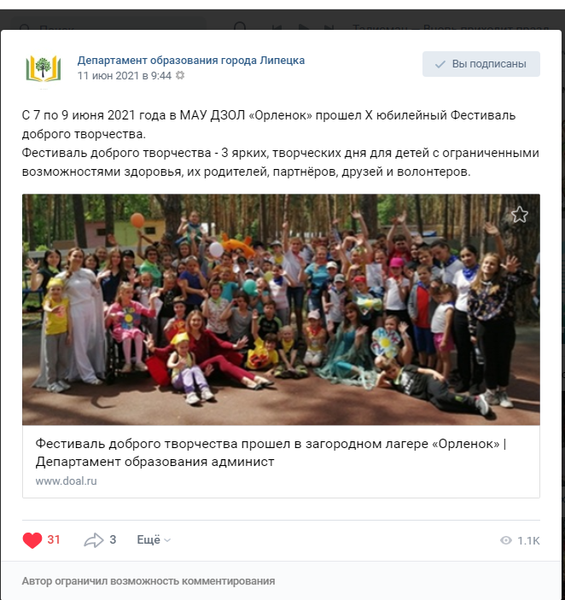

https://vk.com/serg.guliaev?w=wall624954769_67%2Fall\

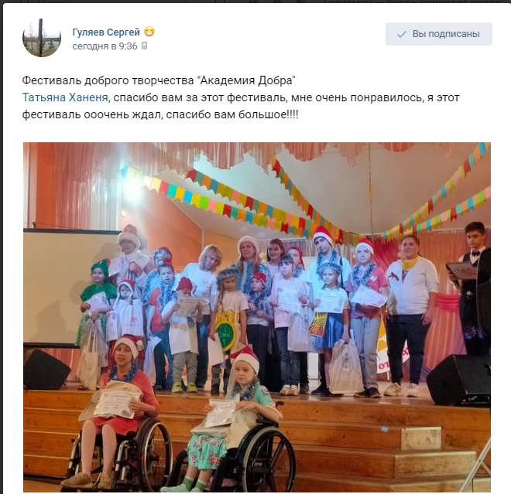

https://vk.com/serg.guliaev?w=wall624954769_71%2Fall

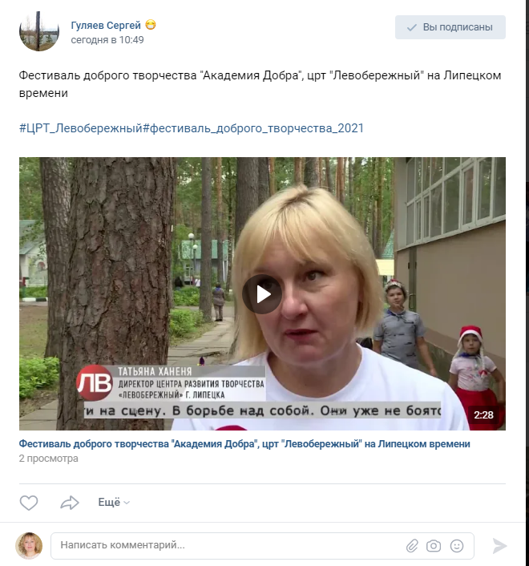

https://vk.com/masham_wedding?w=wall12680432_11017

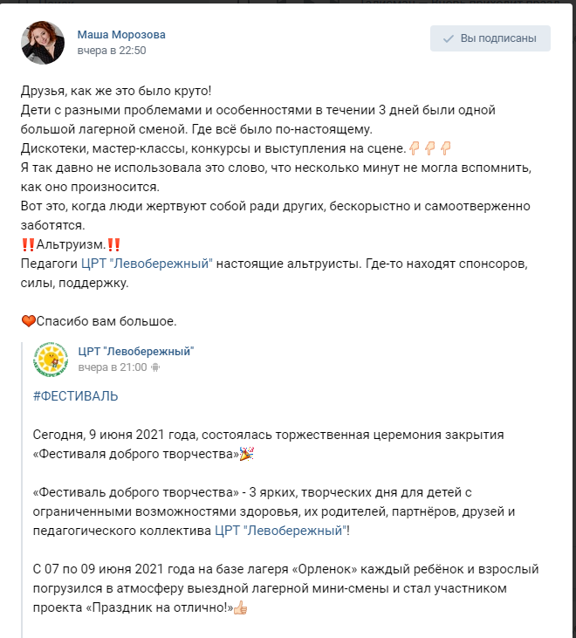
https://vk.com/id356925929?w=wall356925929_1967
