Project code: AICS 12885/01/0

Summary :
During August, the program successfully wrapped up multiple training cohorts and expanded community integration. A total of our four active groups reached graduation this month, including the continuation of our English Pre-Intermediate group, two Intermediate Arabic Language groups, and a newly conducted 8-session CV & Resume Development course. To overcome local infrastructure challenges caused by government roadwork near our facility, the team proactively established strategic field coordination with DOLSA (Department of Labor and Social Affairs) and the Women’s Union Center, enabling uninterrupted session delivery at their facilities. Furthermore, community demand remains strong, with a new Kurdish Language group currently being organized for waiting-list IDP candidates.

# Act. 1.2 Training on basic skills
The training activities for August resulted in the successful graduation of four groups and the implementation of specialized modules:
- CV & Resume Development Course: Designed to enhance job-readiness reached successful graduation this month. The group comprised 8 beneficiaries (2 males, 6 females) all of whom are IDPs residing in the area.
- English Language (Pre-Intermediate Level): Following the completion of their curriculum, this group successfully graduated during August.
- Arabic Language Group A (Intermediate Level): Focused on language proficiency and speaking this group of 8 female beneficiaries (all host community members) completed their final sessions and graduated.
- Arabic Language Group B (Intermediate Level): Also reached full graduated this month, this group served 10 beneficiaries (5 males, 5 females), consisting of 9 host community members and 1 IDP.

Highlights of the month:

Web Development Final Project: Beyond graduation the Web Development &Coding cohort, every single beneficiary successfully created and launched their own final website will be shared alongside this report to showcase their practical coding achievements.

Multiple Cohort Graduations: August marked a high-impact completion phase, with beneficiary’s graduation across four distinct courses CV Development, English Pre-Intermediate, and two Arabic Language groups.

Empowering IDP Youth in Employability: The newly completed CV Development module specifically targeted and graduated 10 IDP participants, equipping them with essential tools for job application and career advancement.

Agile Operational Adaptation Demonstrating strong problem- solving and partnership management, the local team successfully relocated classroom activities to partner Venus to ensure training continuity despite major road renovations around the centre.

Resource Sharing & Operational Partnerships: To maintain instructional continuity during external municipal works, our team established key operational coordination with:
- DOLSA (Department of Labour and Social Affairs): Partnered to host classroom sessions and training activities.
- The Women’s Union Centre: Coordinated facility usage to ensure a safe, accessible learning environment for female beneficiaries during road construction.

Challenges and amendments:
Municipal Infrastructure and Access Constrains: Goverment road renwal works around the center temporarily blocked safe access for beneficiaries. To resolve this, the team adopted swiftly by shifting sessions to the facilities of DOLSA and the Women’s Union Center, preventing any cancellation or delay in the training calendar.

Lessons Learned

Value of Flexible Community Infrastructure: Establishing active links with local public and community entities like DOLSA and the women’s Union Center) provides essential backup space when external physical or environmental abstacles aries.

Targeted Career Guidence for Displaced Youth: The enthusiastic completion of the CV group highlights the continouns neccessity for professional soft-skills training tailored to IDPs seeking workforce entry.

Plan for next Month

# | Activities/Output# | due date
1 | Launch of new Kurdish Language Course | September 2026
2
3
5
6
7

English Language

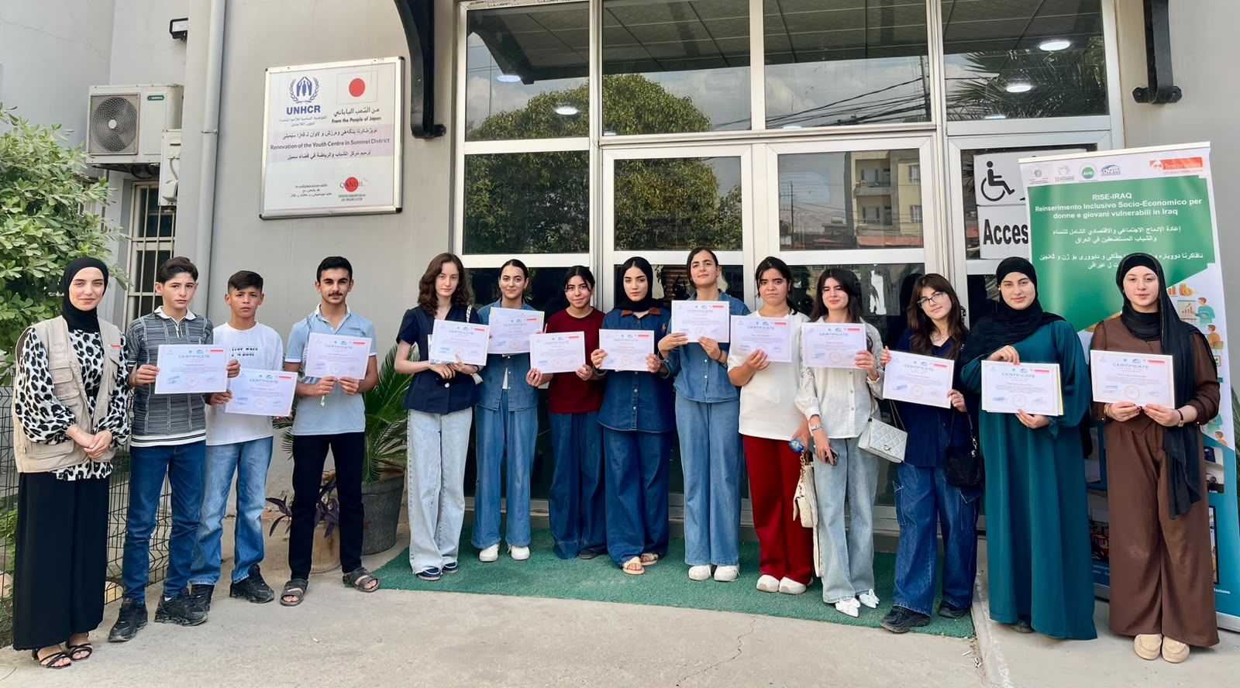
Arabic Language

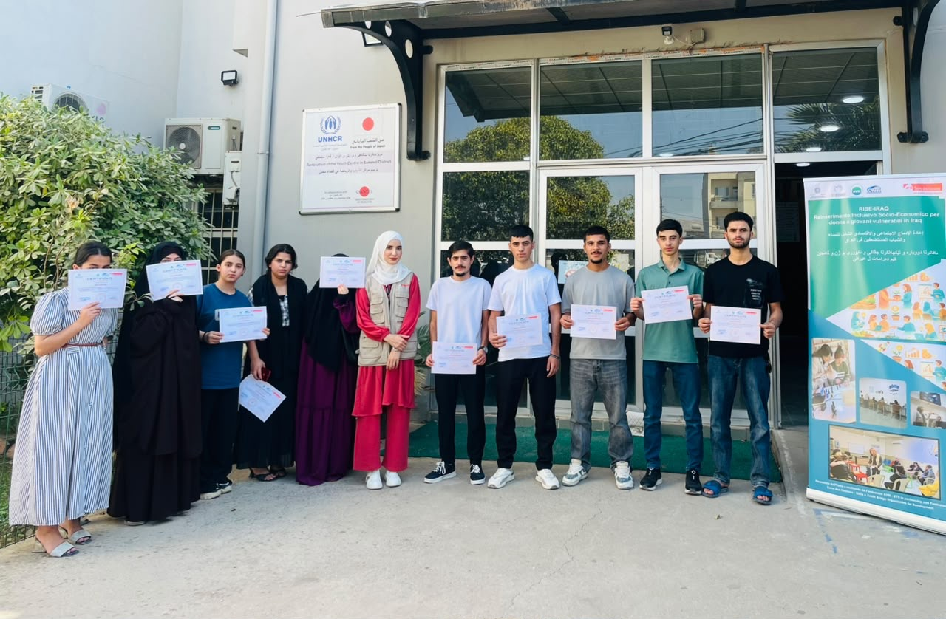

CV Development

