**Фотография: игры с облаками**

[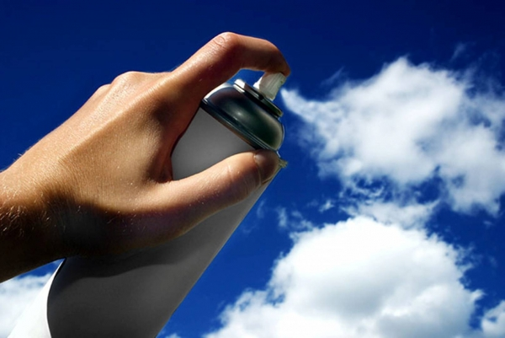](http://c1.emosurf.com/0002xg0sfsq6/416489465.jpg)

[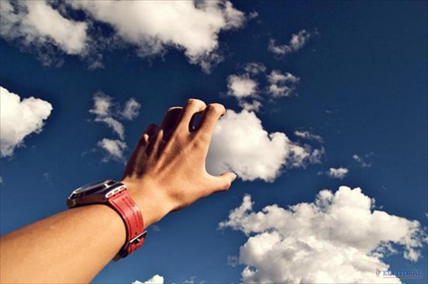](http://c1.emosurf.com/0002xh0o7DR0/ElLitoral-203186-1400x840.jpg)

[](http://c1.emosurf.com/0002xu0g50c6/untitled.jpeg)

[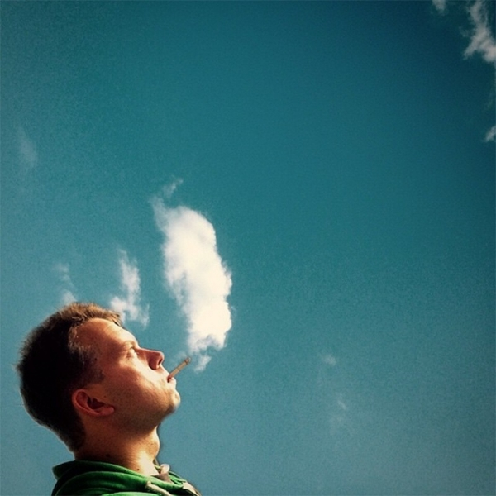](http://c1.emosurf.com/0002xj0da2aM/1416557434738.jpg)

[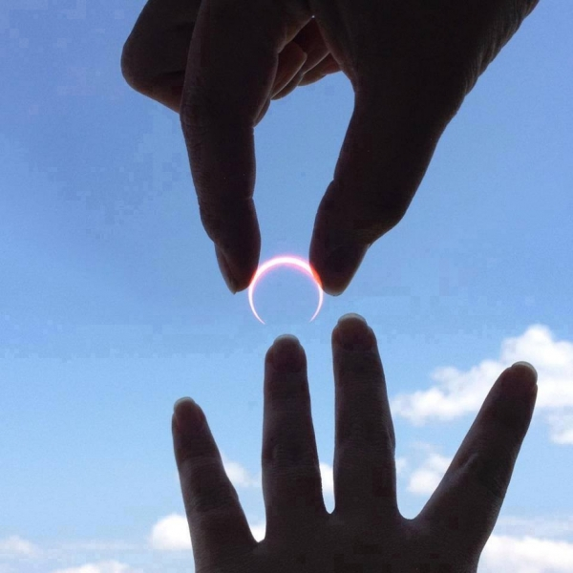](http://c1.emosurf.com/0002xk12VzsS/ilusion1.jpg)

[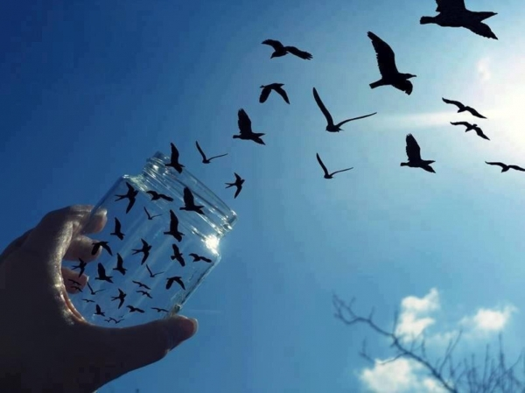](http://c1.emosurf.com/0002xl0Dx3GR/42562d55aec90754736ea3a780fa4453.jpeg)

[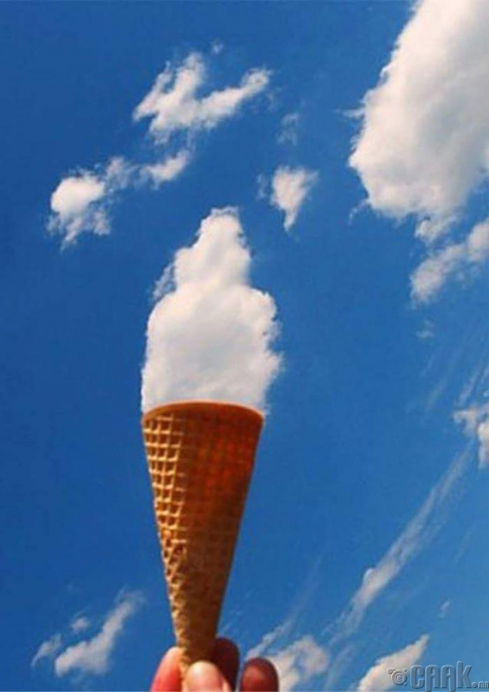](http://c1.emosurf.com/0002xm0Yj7OL/19.jpg_watermarked_aZJ2H3i.jpeg)

[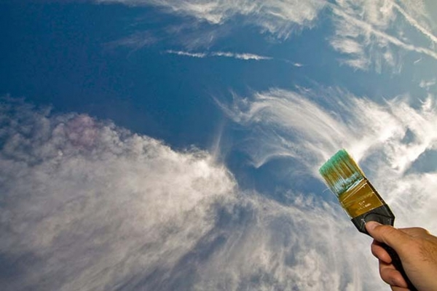](http://c1.emosurf.com/0002xn114I7N/1001530.jpg)

[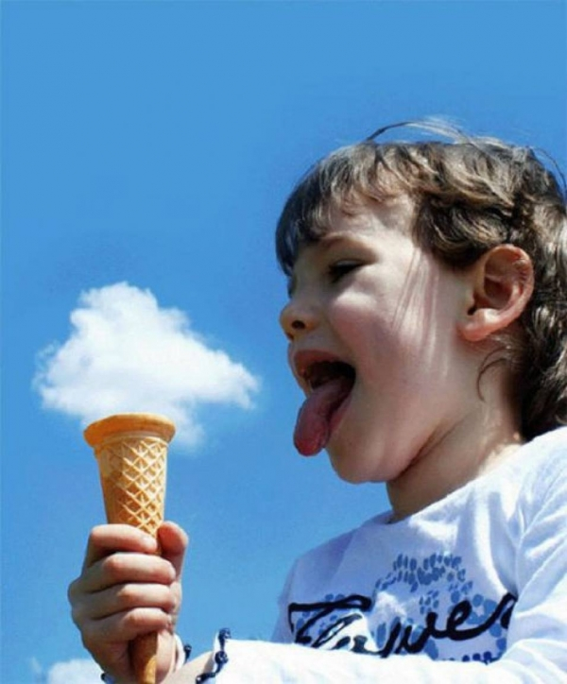](http://c1.emosurf.com/0002xo0zhS0P/e82b613f28edba59f31f7772feafc28c.jpg)

[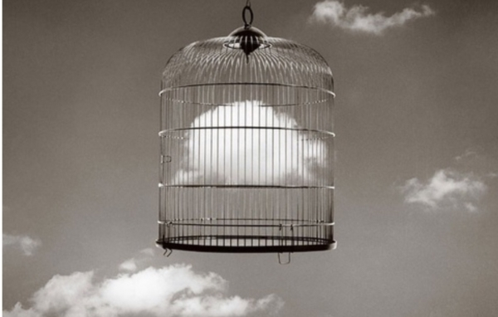](http://c1.emosurf.com/0002xp0V16Jn/tumblr_nz2qqpmIjn1rw44zvo5_1280.jpg)

[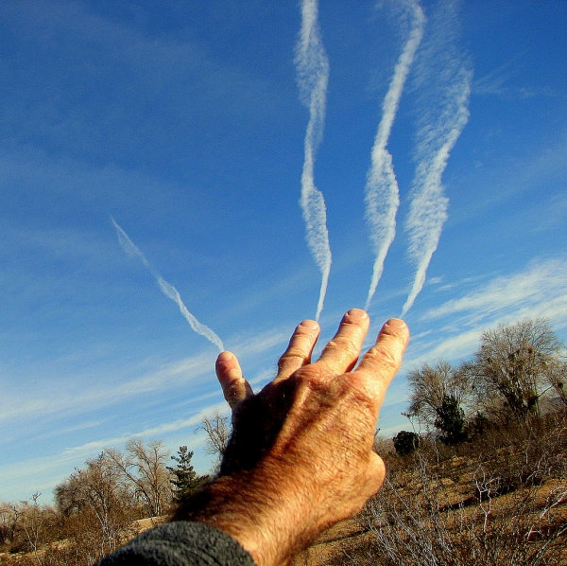](http://c1.emosurf.com/0002xq0kXI3m/db02d410f8cb80e9ddbaaab546b052a3.jpg)

[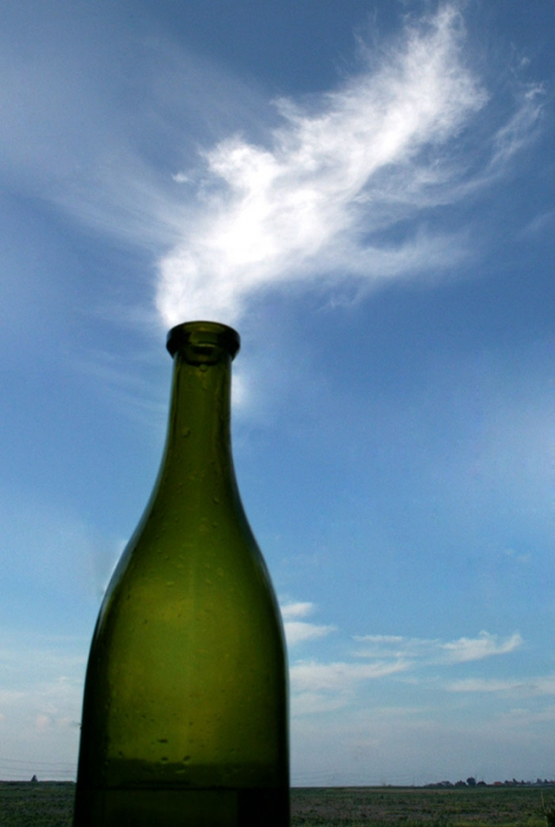](http://c1.emosurf.com/0002xr0UzTPX/72.jpg)

[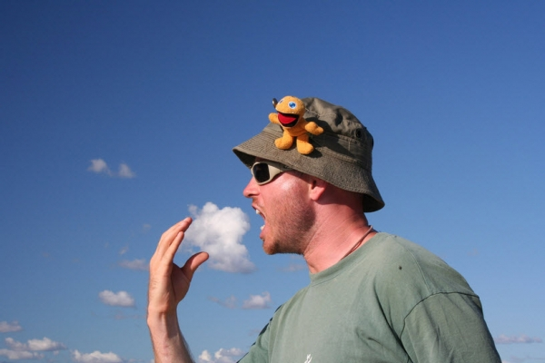](http://c1.emosurf.com/0002xs13fdvo/Forced-Perspective-Photography-Technique-60.jpg)

[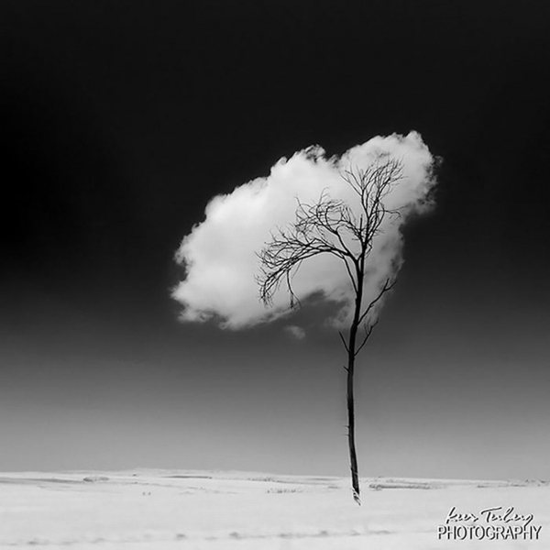](http://c1.emosurf.com/0002xt0aHi5z/1430138883_Amazing-cloud-formations%2520%289%29.jpg)

[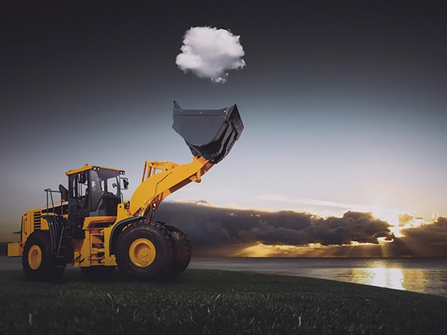](http://c1.emosurf.com/0002xv0au1fT/LAS-MEJORES-FOTOS-JAMAS-TOMADAS-5.jpg)

[](http://c1.emosurf.com/0002xw0A3eYT/untitled.png)

[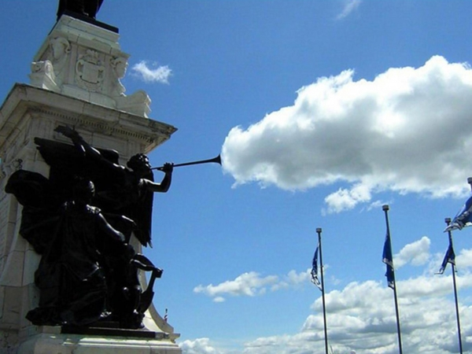](http://c1.emosurf.com/0002xx0jcScr/b586bcf0cb2d243827d09df9d6349879.jpg)