[**Какие скульптуры можно сделать из снега?**](http://emosurf.com/post/4708/Kakie_skulptury_mozhno_sdelat_iz_snega%3F)

[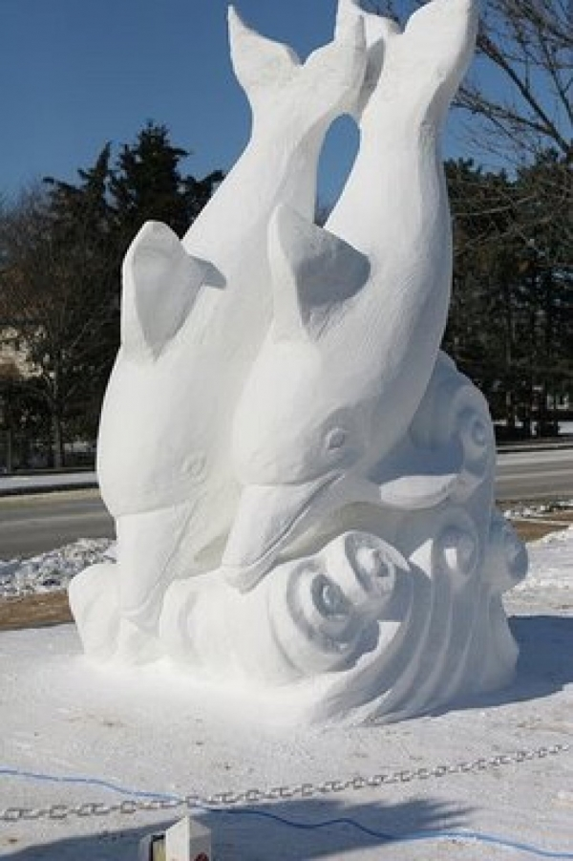](http://c1.emosurf.com/0002hd0YaF1h/_122_321825584.jpg)

[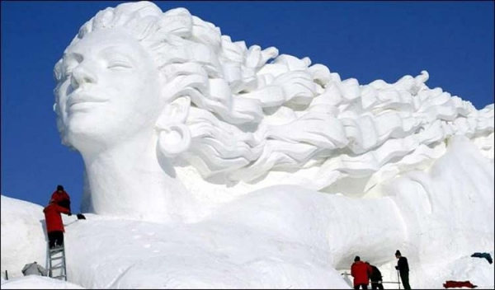](http://c1.emosurf.com/0002he0ne9cj/sculptures-sur-neige-055.jpg)

[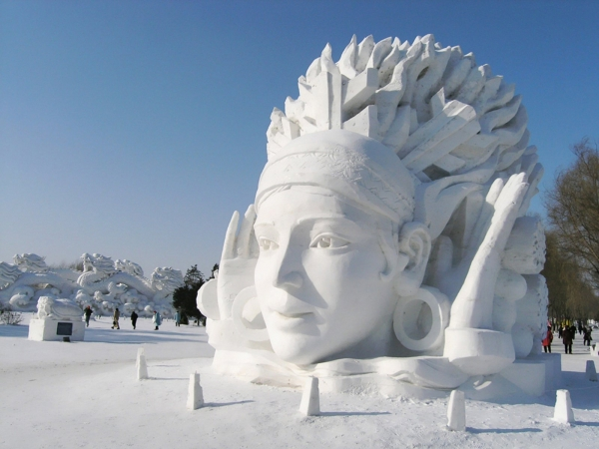](http://c1.emosurf.com/0002hf0nANYR/sapporo-snow-festival-514.jpg)

[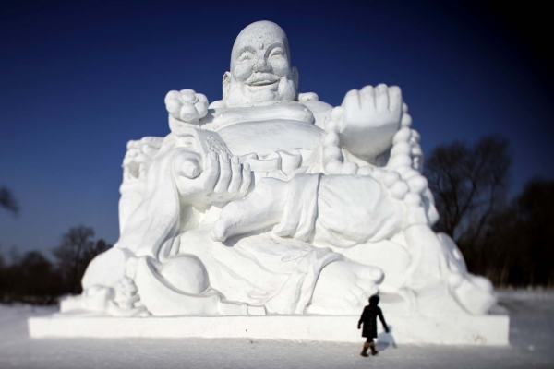](http://c1.emosurf.com/0002hz0eeOqn/1357483805_38.jpg)

[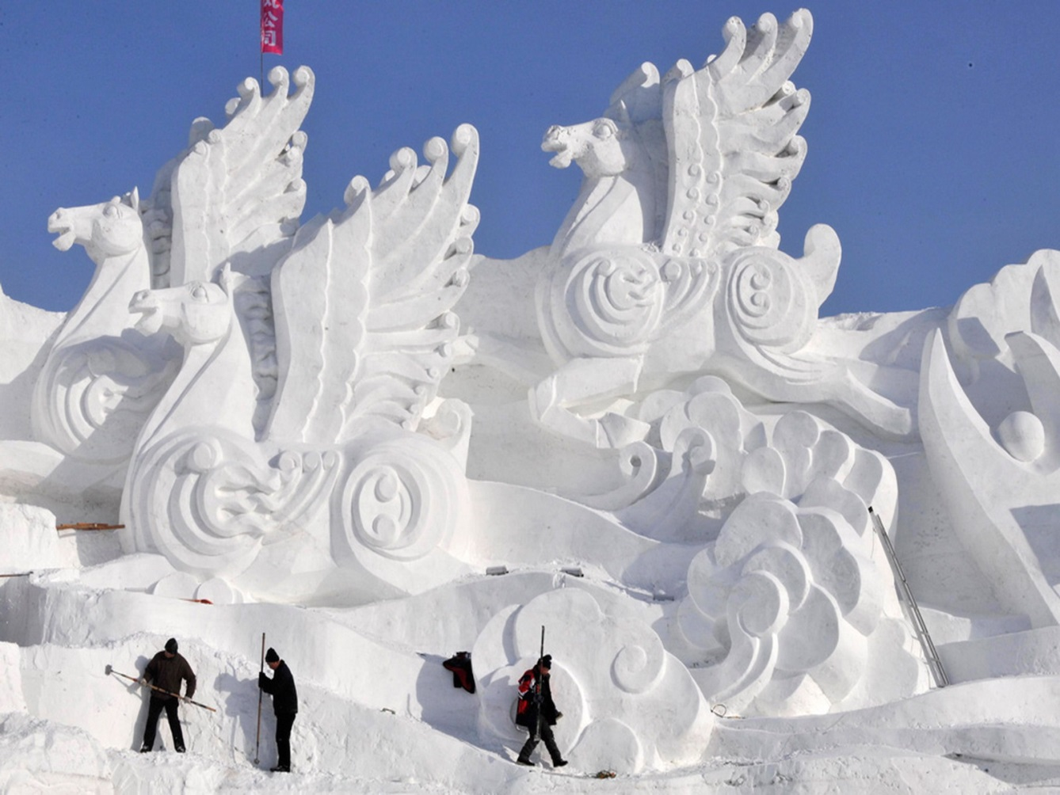](http://c1.emosurf.com/0002hh0iC4g9/harbin-09.jpg)

[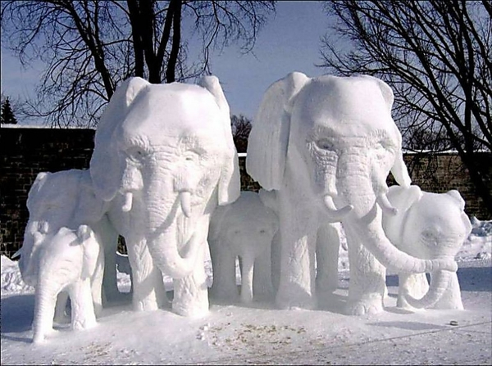](http://c1.emosurf.com/0002hi0egHUN/9f15723ec734a8eaadc95db4edb931ef.i1200x895x686.jpeg)

[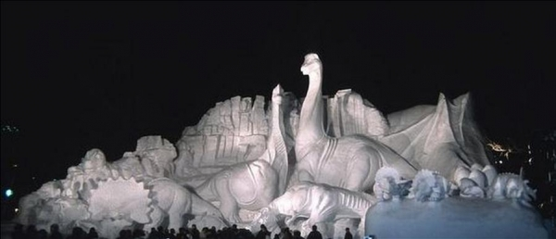](http://c1.emosurf.com/0002hj0A09CJ/Pictures+SNOW+SCULPTURES+14.jpg)

[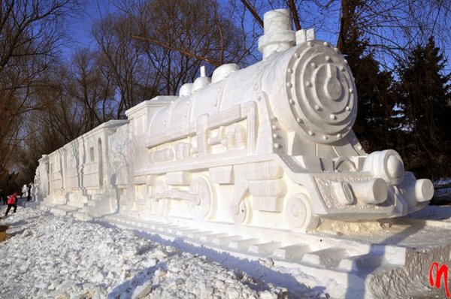](http://c1.emosurf.com/0002hk11uSgz/MTI4OTg1NjEyNTMwMjYwNDQ2.jpg)

[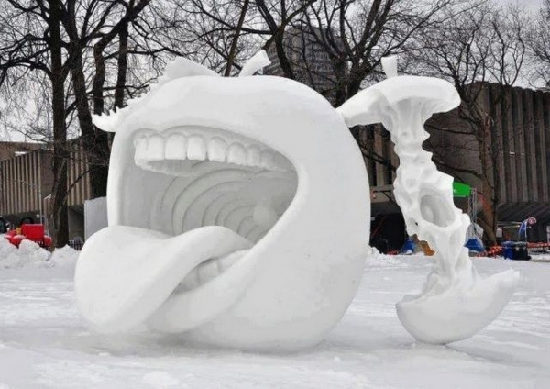](http://c1.emosurf.com/0002hl0VHnj4/Mu%C3%B1eco-de-nieve-8.jpg)

[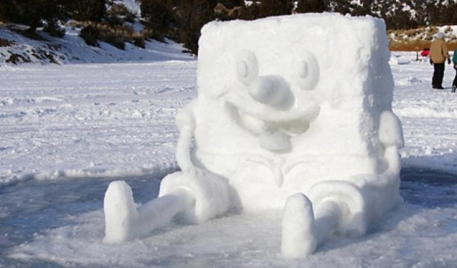](http://c1.emosurf.com/0002hm08KIsj/sunger-kardan-sort_780x460-h46y3pf7va.jpg)

[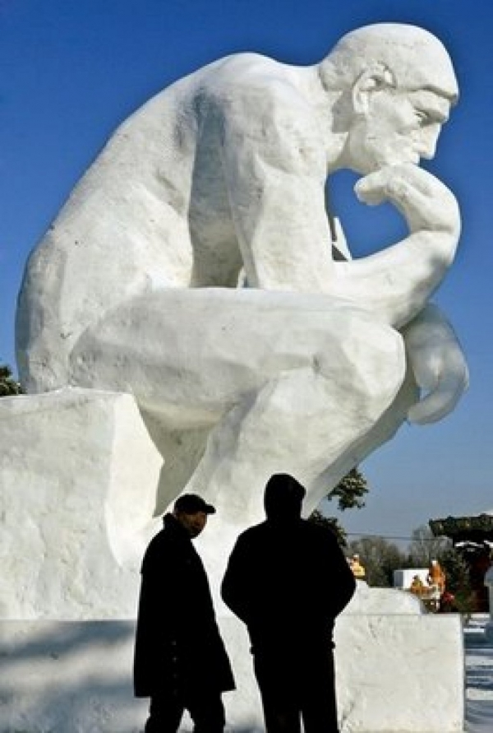](http://c1.emosurf.com/0002hn0g4WDq/_122_321822641.jpg)

[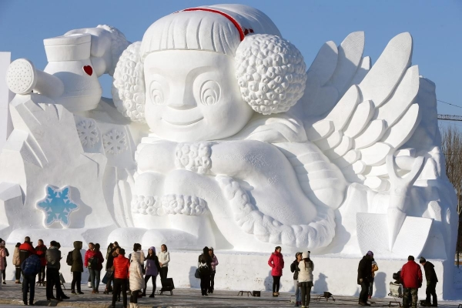](http://c1.emosurf.com/0002ho0htrEn/creaciones-con-hielo.jpg)

[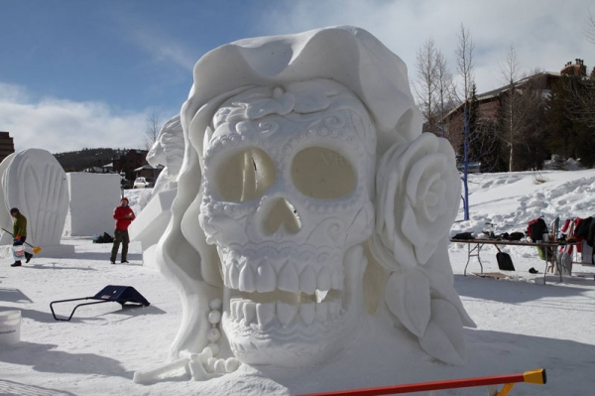](http://c1.emosurf.com/0002hp0kzo8F/international-snow-sculpting-championships-2016-breckenridge-colorado-15.jpg)

[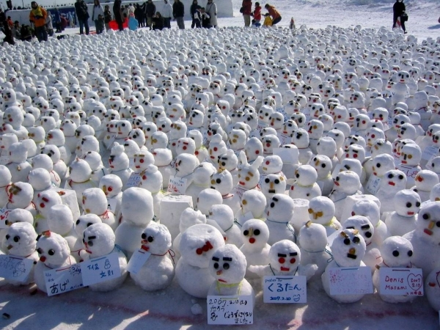](http://c1.emosurf.com/0002hq0hmLL0/11895_sapporo_snow_festival.jpg)

[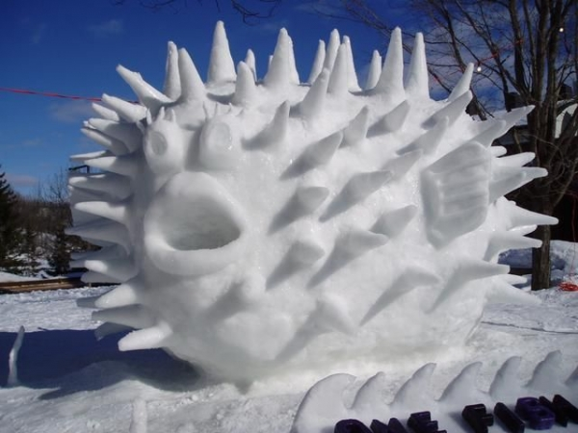](http://c1.emosurf.com/0002hr0lNw3T/800823fc15baded5808bfc6c9d46a986.jpg)

[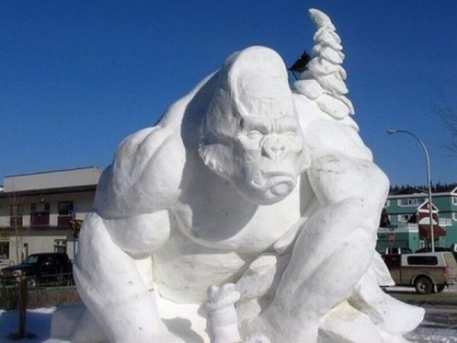](http://c1.emosurf.com/0002hs14Af4b/a63548d1.jpg)

[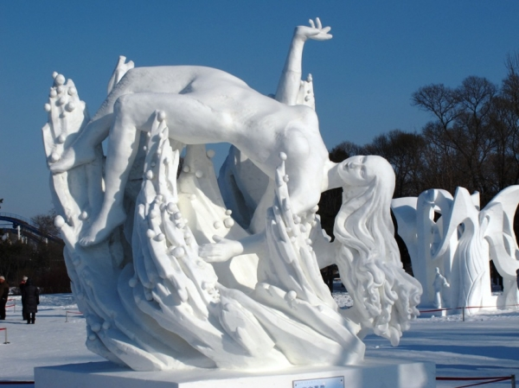](http://c1.emosurf.com/0002ht02d6t8/untitled.jpeg)

[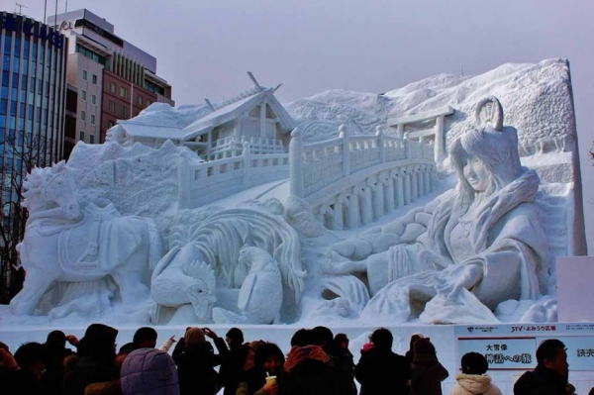](http://c1.emosurf.com/0002hu0AadzT/untitled.jpeg)

[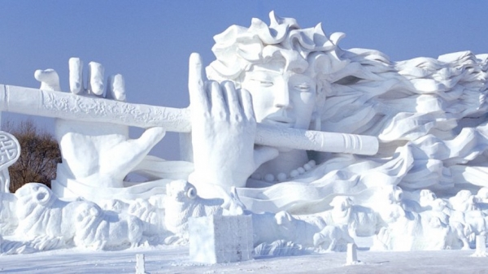](http://c1.emosurf.com/0002hv0ci7Cb/china.jpg)

[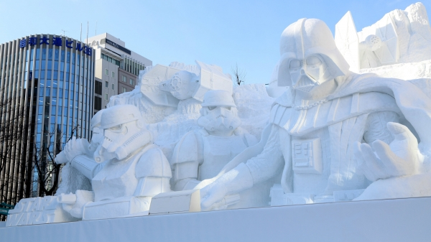](http://c1.emosurf.com/0002hw0mgObg/r_d2c8657.jpg)

[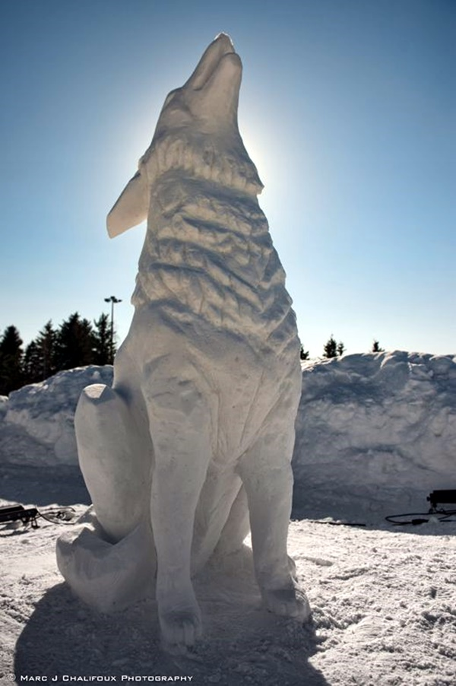](http://c1.emosurf.com/0002hx0iLjae/Realistic-Snow-Art-Sculptures-Winter-Creations-3.jpg)

[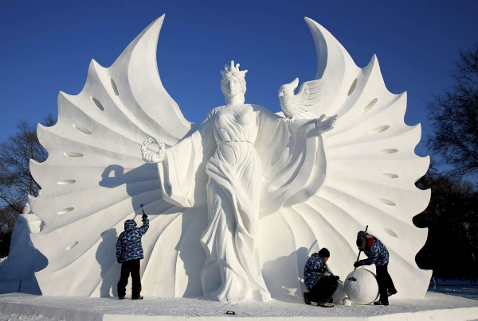](http://c1.emosurf.com/0002hy0dwk9v/ss-150107-harbin-07.today-ss-slide-desktop.jpg)